# BloodBridge: Optimizing Lifesaving Resources using AWS services

**Project Description:**

"BloodBridge" is a comprehensive web-based blood bank management system designed to streamline the process of blood donation and distribution. The project leverages Amazon Web Services (AWS) for robust and scalable infrastructure, utilizing Amazon RDS for secure and efficient data storage and Amazon EC2 for reliable web hosting. The user-friendly web interface allows individuals to register and log in to their personal accounts, creating a seamless experience for both donors and recipients. Once logged in, users are presented with a dashboard that serves as a central hub for all blood-related activities.

The dashboard prominently features current blood requests, allowing users to view real-time needs in their community. Additionally, registered users can easily submit their own blood requests, specifying blood type, quantity, and urgency. This system not only facilitates quick responses to critical blood needs but also fosters a sense of community engagement in the life-saving act of blood donation. By combining modern cloud technology with an intuitive user interface, "BloodBridge" aims to bridge the gap between blood donors and those in need, ultimately saving lives and improving healthcare outcomes.

**Scenario 1:** **Emergency Blood Request**

Sarah, a hospital administrator, logs into LifeLink during a critical situation. A patient needs a rare blood type urgently. Using her dashboard, Sarah quickly submits a high-priority blood request, specifying the required blood type and quantity. The system immediately notifies potential donors in the area, significantly reducing the time to find a match and potentially saving the patient's life.

**Scenario 2**: **Regular Donor Management**

John, a regular blood donor, uses LifeLink to manage his donations. After logging in, he checks his dashboard to see when he's eligible to donate again. He notices a nearby blood drive event listed in the requests section. John uses the system to schedule his next donation, helping maintain a steady supply of blood for the local hospitals.

**Scenario 3: Blood Bank Inventory Update**

A blood bank manager, Lisa, uses LifeLink to update the current blood inventory. She logs into her specialized account and accesses a feature to input the latest stock levels for each blood type. The system automatically updates the dashboard for all users, reflecting the current needs. This real-time update helps prioritize requests for blood types that are running low, ensuring efficient distribution of this vital resource.

**Technical Diagram:**

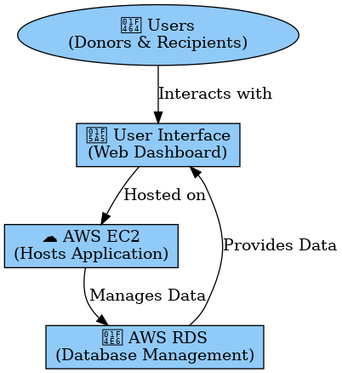

**ER Diagram:**

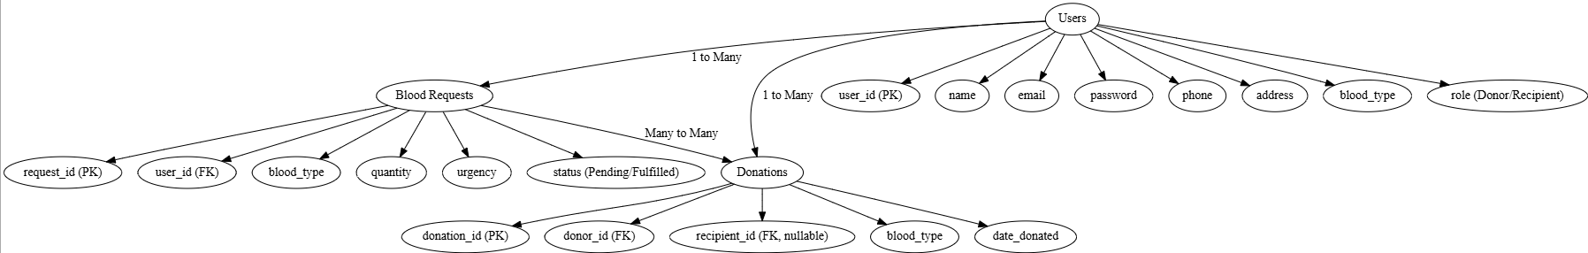

**Prior Knowledge:**

### 1. AWS Account Setup: [https://youtu.be/CjKhQoYeR4Q?si=ui8Bvk_M4FfVM-D](https://youtu.be/CjKhQoYeR4Q?si=ui8Bvk_M4FfVM-Dh)h

### 2.Web Application Stack : [FLask](https://www.youtube.com/results?search_query=flask+tutorial) || [MySQL Connector using flask](https://www.youtube.com/results?search_query=mysql+connector+for+flask) || [HTML/JS/CSS](https://www.youtube.com/results?search_query=html+js+css+tutorial+)

### 3. AWS EC2 Instance: <https://www.youtube.com/results?search_query=aws+ec2+oneshot>

### 4. RDS Database: <https://www.youtube.com/results?search_query=rds+oneshot>

### 5. MySQL: <https://www.youtube.com/results?search_query=mysql+tutorial>

### 6. RDS connects MySQL:<https://www.youtube.com/results?search_query=mysql+connector+for+rds>

### 7. Clone Git repo: <https://www.youtube.com/results?search_query=clone+github+repository>

### 8. AWS Cost Management: <https://youtu.be/OKYJCHHSWb4?si=aY3DQl1v26CfZxXA>

**Project Workflow:**

## **1. AWS Account Setup**

* Create an AWS account and configure billing settings.
* Access the AWS Management Console to set up services.

## **2. RDS Database Setup**

* Create an Amazon RDS instance using MySQL.
* Configure database security, set up credentials, and define a schema for BloodBridge.
* Tables Creation:
  + users(Donors & Recipients)
  + blood_requests(Track blood needs)
  + donations(Record donor contributions)

## **3. MySQL Database Configuration**

* Set up MySQL on the RDS instance.
* Configure tables for users, blood requests, and donations.
* Implement queries for operations like request creation, donor registration, and tracking donations.

## **4. EC2 Instance Launch**

* Launch an AWS EC2 instance to host the BloodBridge platform.
* Configure security groups to allow HTTP/HTTPS traffic.
* Connect EC2 to RDS for database access.
* Deploy the Flask application on EC2.

## **5. Flask Backend Development**

* Integrate Flask with the MySQL database on RDS.
* Implement API endpoints for:
  + User registration & authentication
  + Blood request creation & tracking
  + Donor registration & matching

## **6. HTML & CSS Frontend Development**

* Develop an interactive UI using HTML, CSS, and JavaScript.
* Design pages for:
  + User registration & login
  + Blood request submission & tracking
  + Donor registration & matching system
* Connect the frontend to Flask backend for real-time updates.

## **8. Monitoring & Maintenance**

* Use AWS CloudWatch to monitor:
  + EC2 performance & traffic
  + RDS database queries & storage
* Set up alerts for system performance & database health.

## **Milestone 1: AWS Account Creation and Login**

In this milestone, we will set up an AWS account to access the necessary services for the BloodBridge project.

**Activity 1: Create AWS Account**

1. Go to the AWS website (<https://aws.amazon.com/>).
2. Click on the "Create an AWS Account" button.
3. Follow the prompts to enter your email address and choose a password.
4. Provide the required account information, including your name, address, and phone number.
5. Enter your payment information. (Note: While AWS offers a free tier, a credit card or debit card is required for verification.)
6. Complete the identity verification process.
7. Choose a support plan (the basic plan is free and sufficient for starting).
8. Once verified, you can sign in to your new AWS account.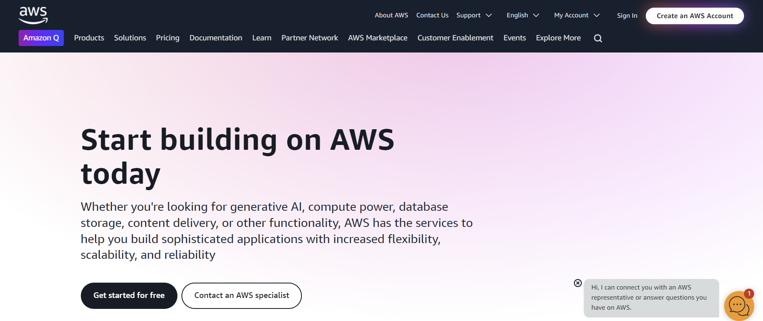

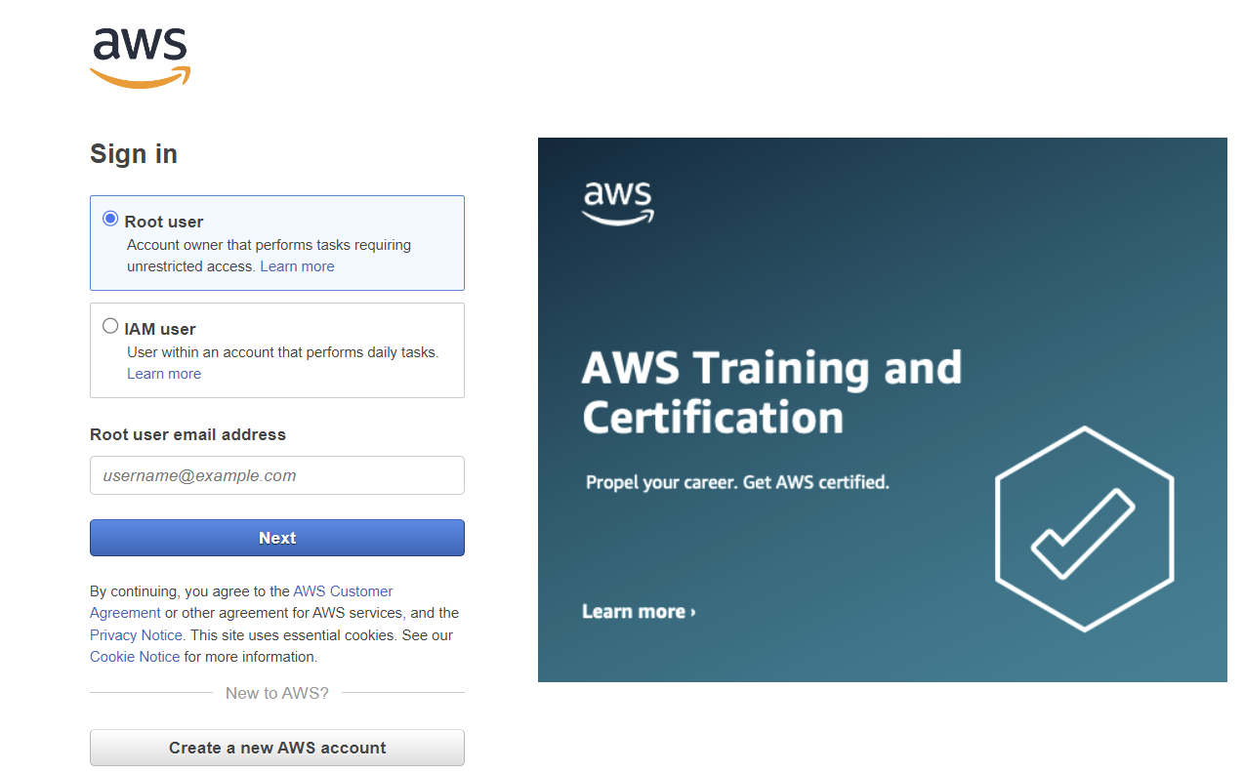

**Milestone 2: RDS Database Creation and Setup**

In this milestone, we will create and configure an RDS instance with MySQL to store and manage BloodBridge data.

1. Access RDS Console: From the AWS Management Console, go to the RDS service.
2. Create Database: Click on "Create database" and follow the wizard:
   * Choose MySQL as the engine type.
   * Select the appropriate version and instance size.
   * Configure storage, network settings, and security groups.
   * Set up the master username and password.
   * VPC and Subnet: Ensure the RDS instance is in the same VPC as your EC2 instance.
   * Public Accessibility: Enable this option if you need direct access from outside the VPC (not recommended for production).
   * Security Group: Create or use an existing security group that allows MySQL traffic (default port 3306).
   * Set an initial database name (e.g., `bloodbank`).
3. Review and Create: Review your database configuration and create the instance.

* **Activity 2.1: Create an RDS Instance**
  + Choose the RDS service from the AWS Management Console.

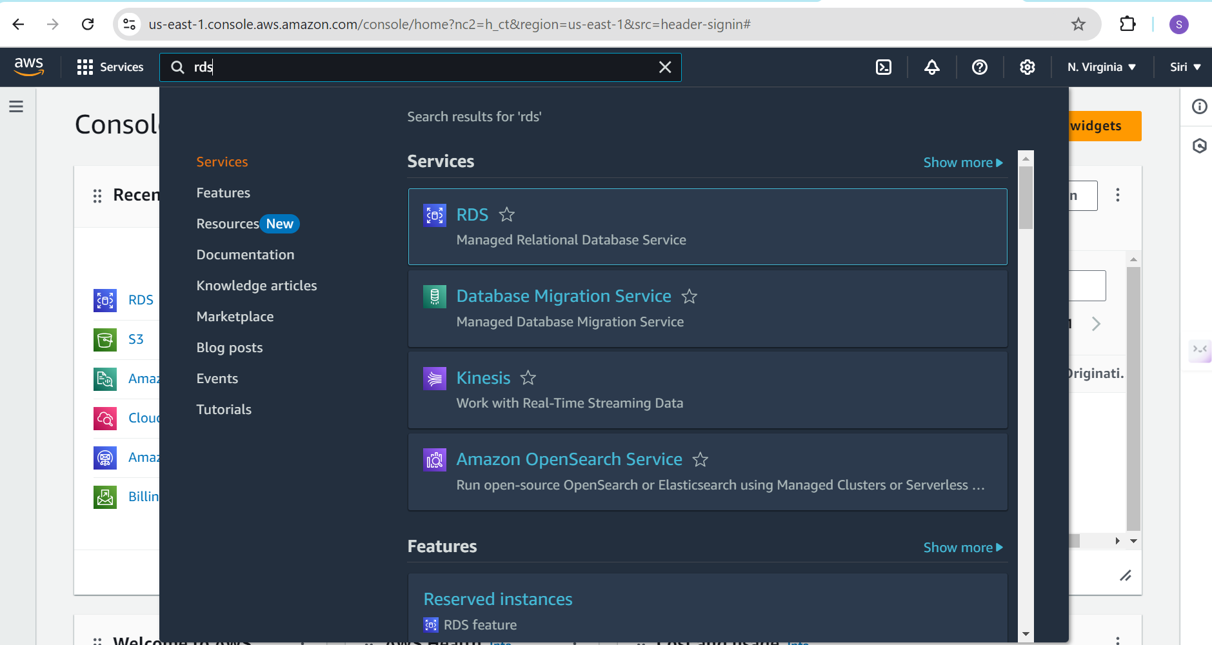

* The RDS interface

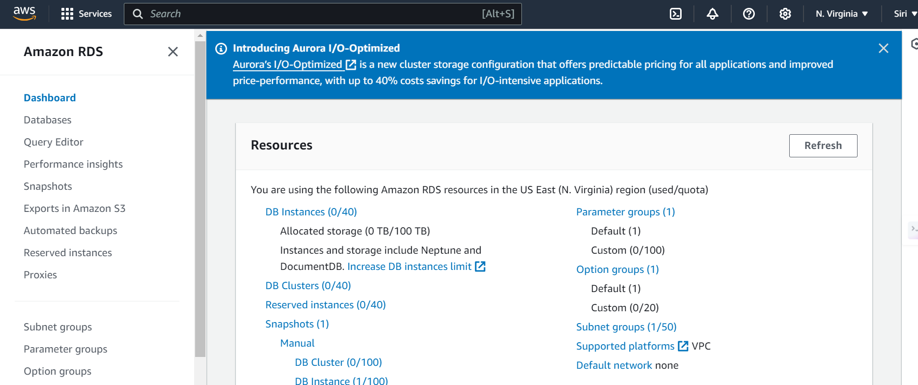

* Click on create database

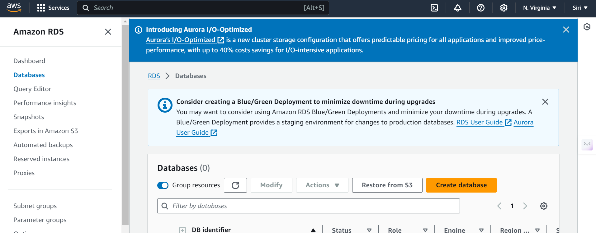

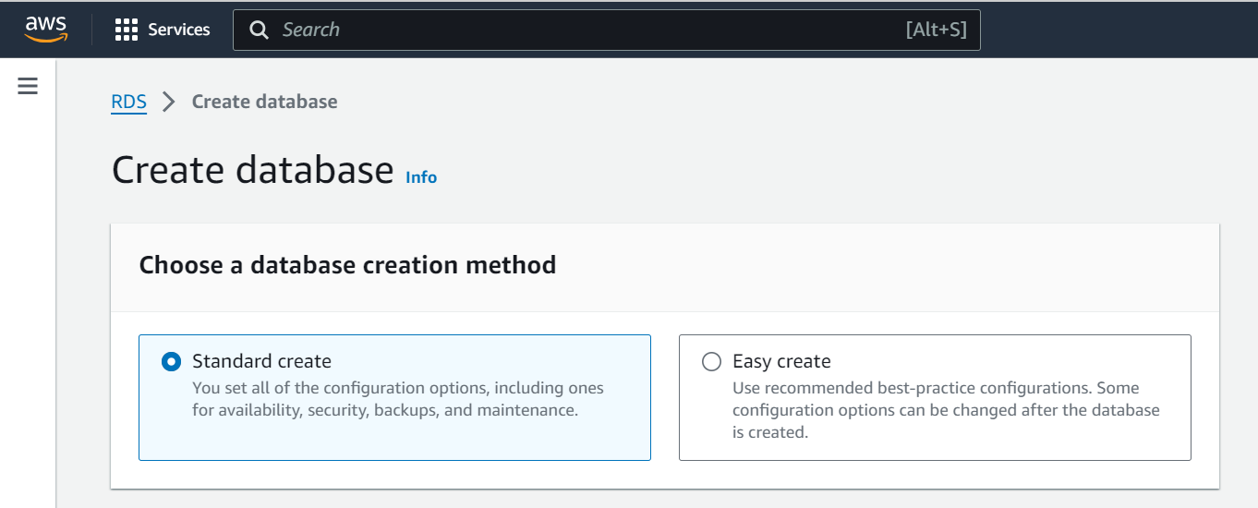

* Select Standard create
* Choose MySQL

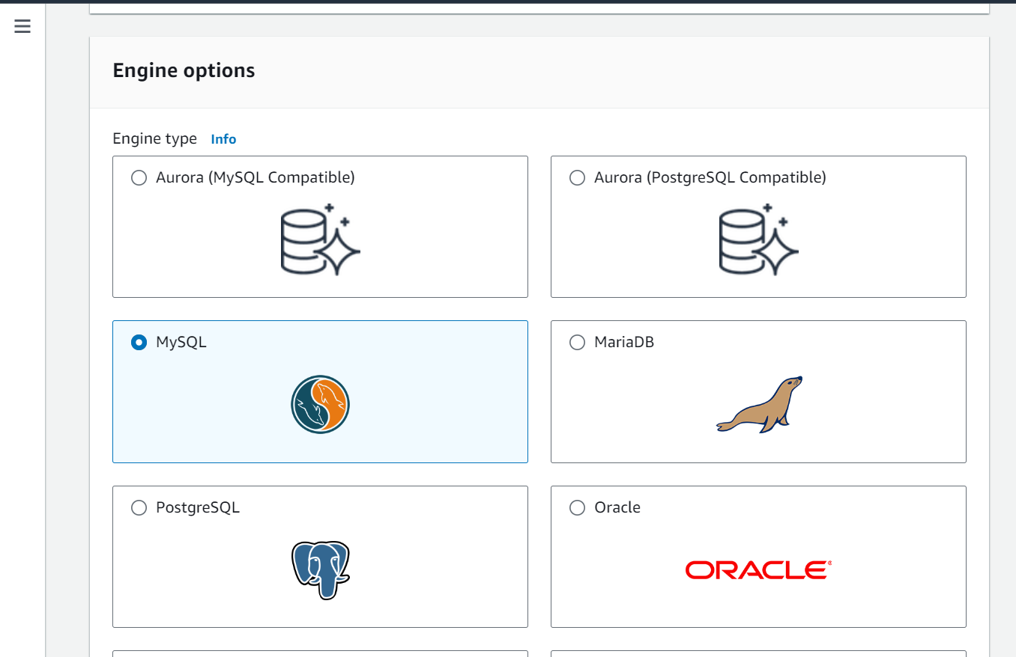

* Choose the version of MySQL

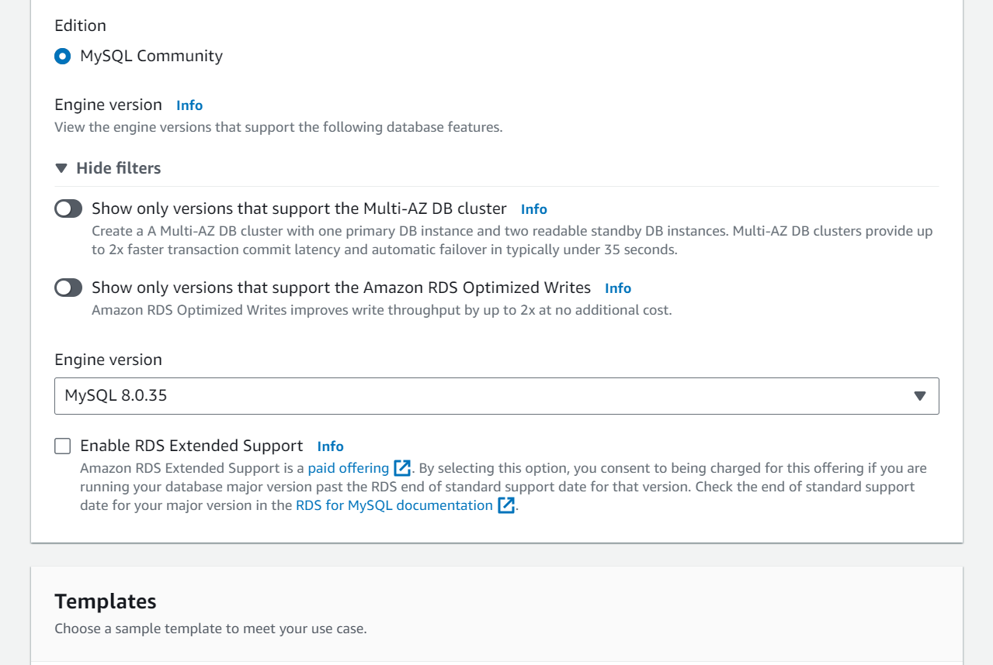

* Choose free tier

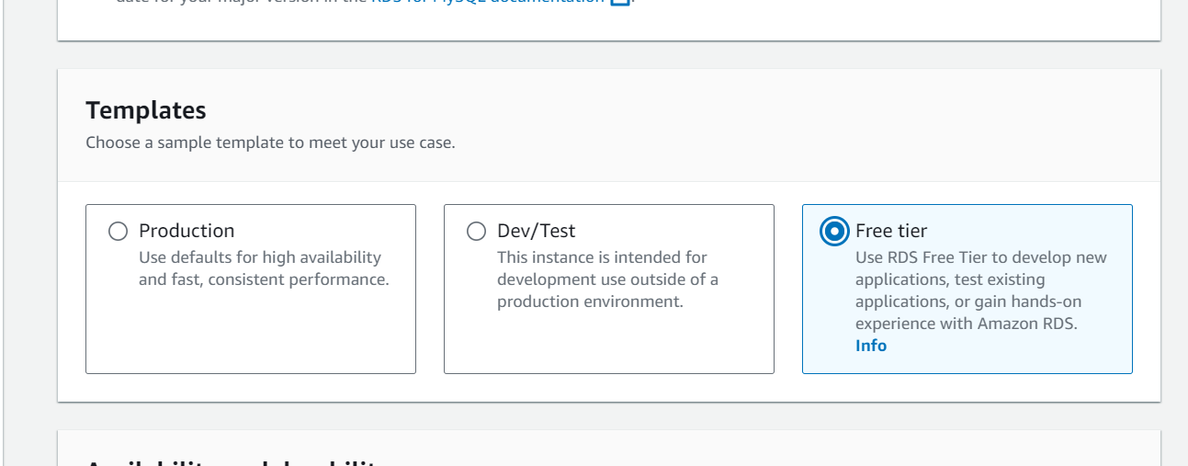

* Choose self managed

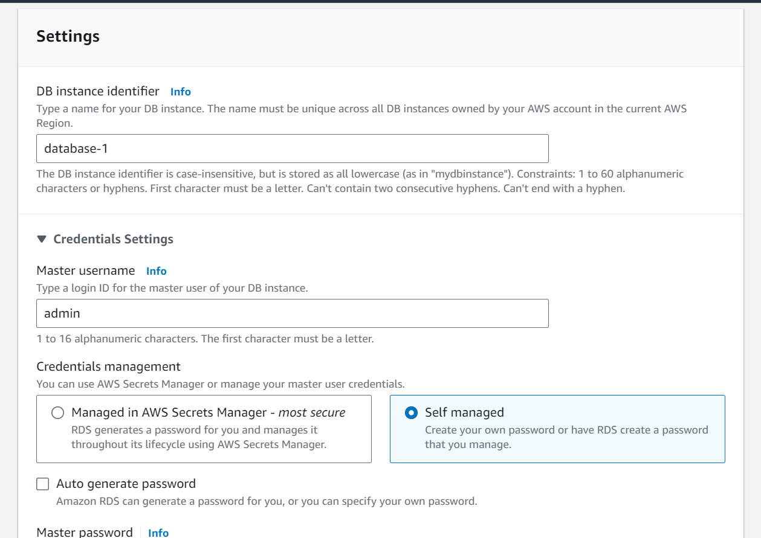

* Create a strong password for your RDS

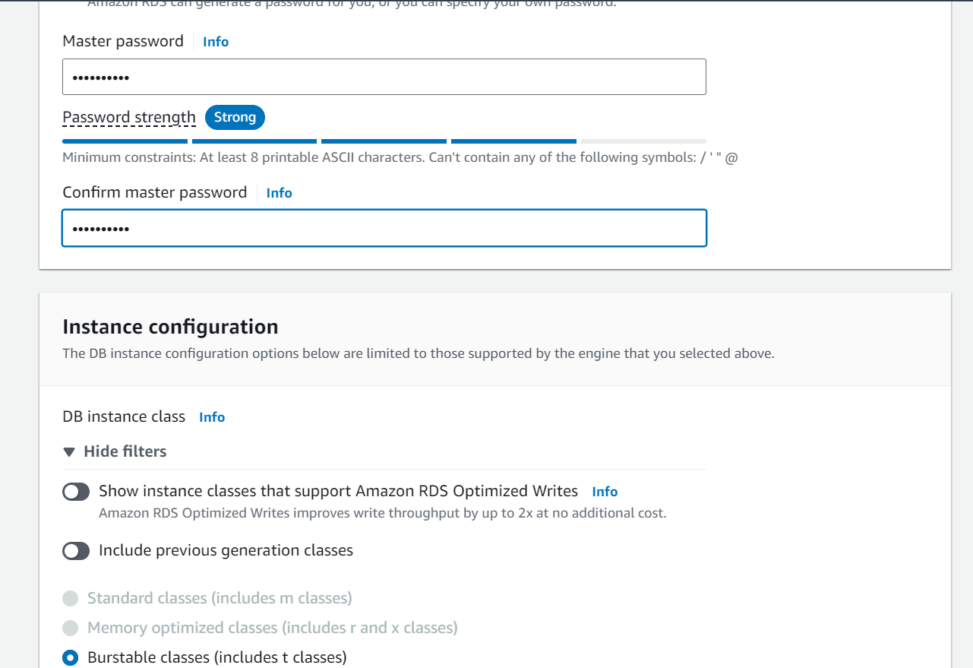

* Choose db.t4g.micro

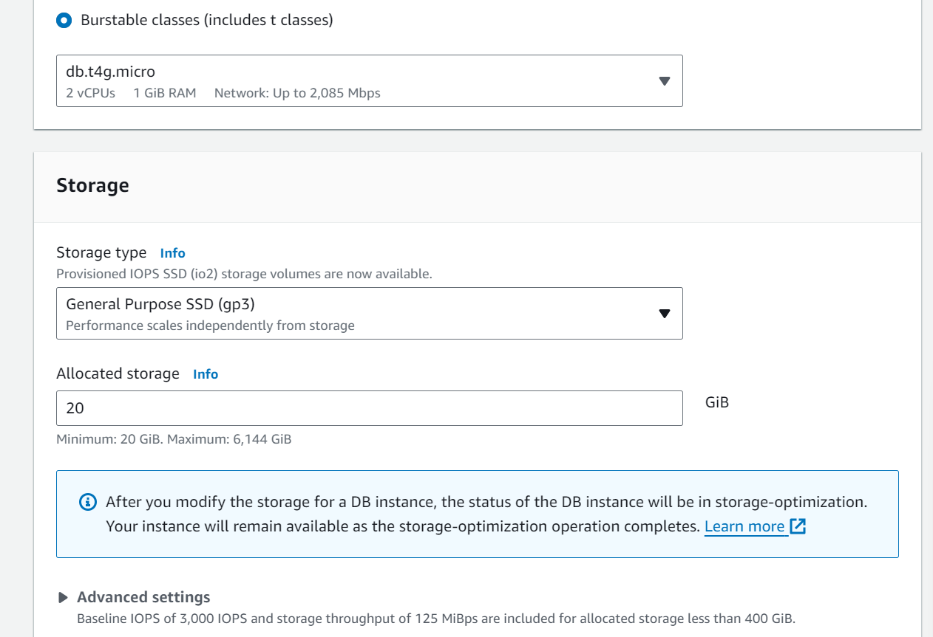

* Choose don’t connect to an EC2 computer resource

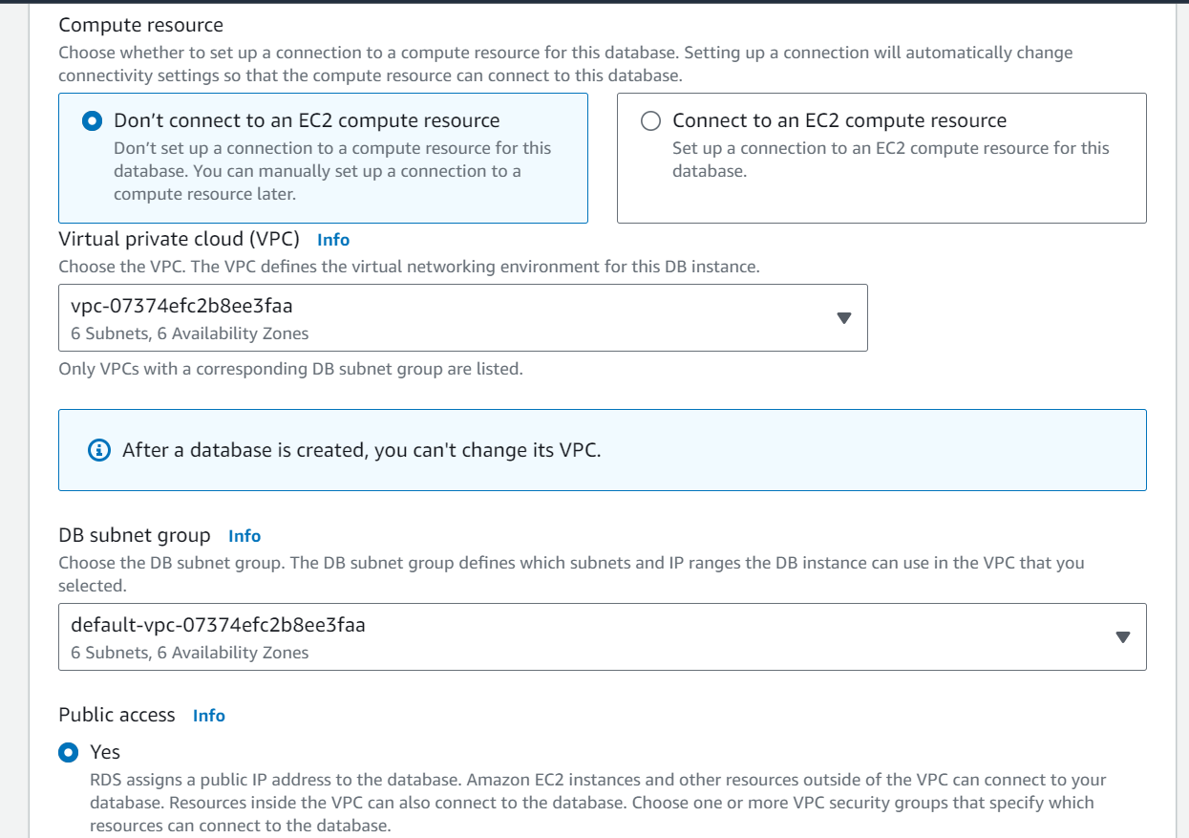

* Create a new VPC and name it.

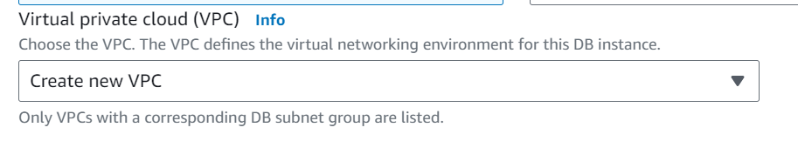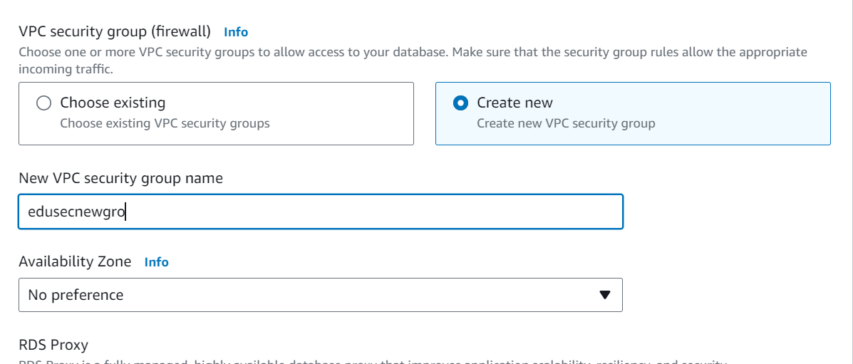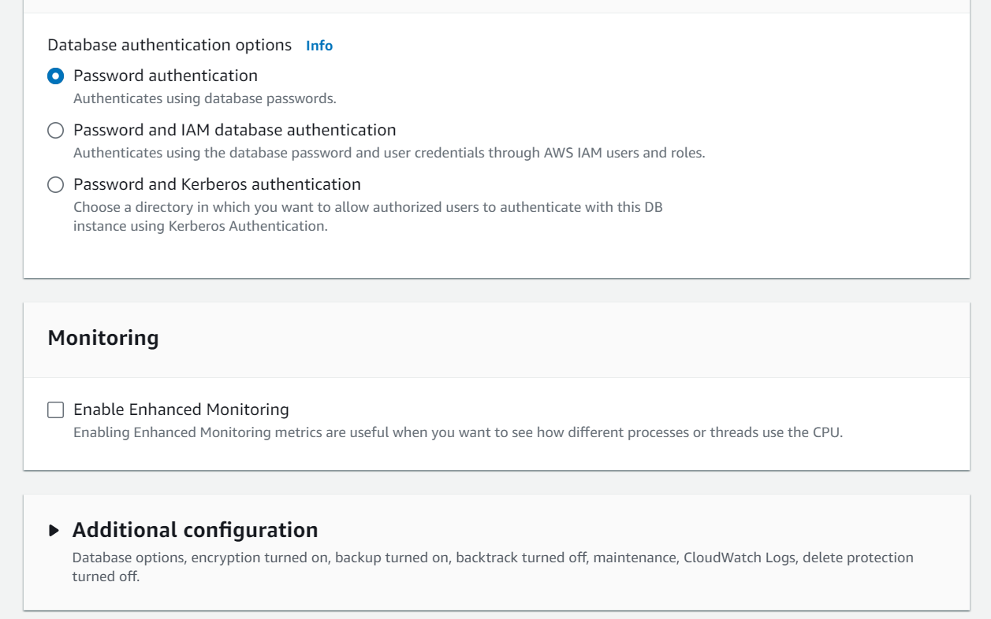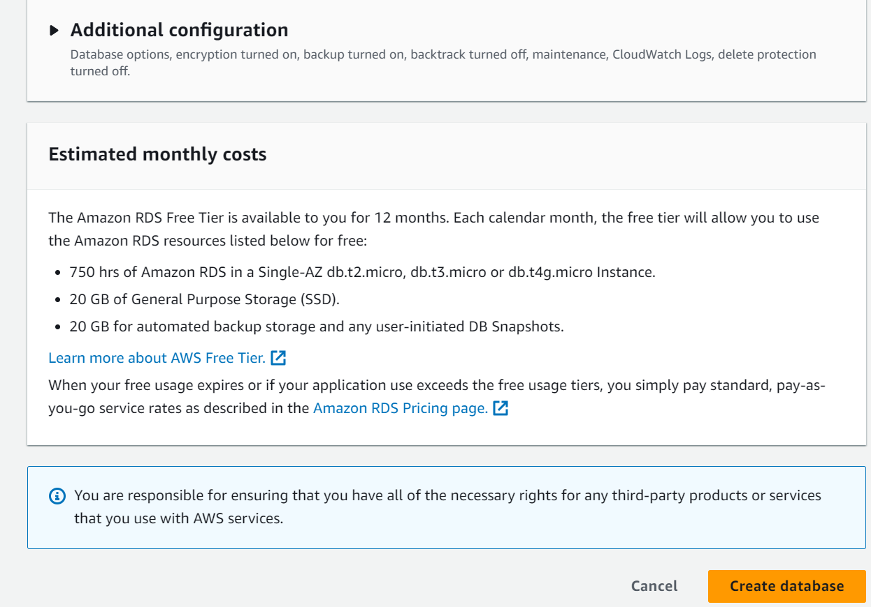Finally, click on Create Database

* **Activity 2.2: Configure Database Access**
  + Set up security groups, create database credentials, and configure access policies to ensure secure connectivity to the database.
* **Activity 2.3: Install MySQL Workbench**

Download and install MySQL Workbench on your local machine for database management.

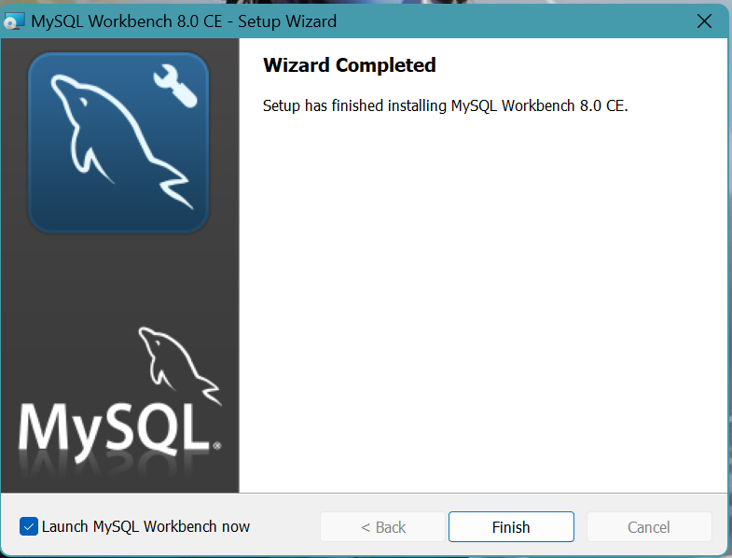

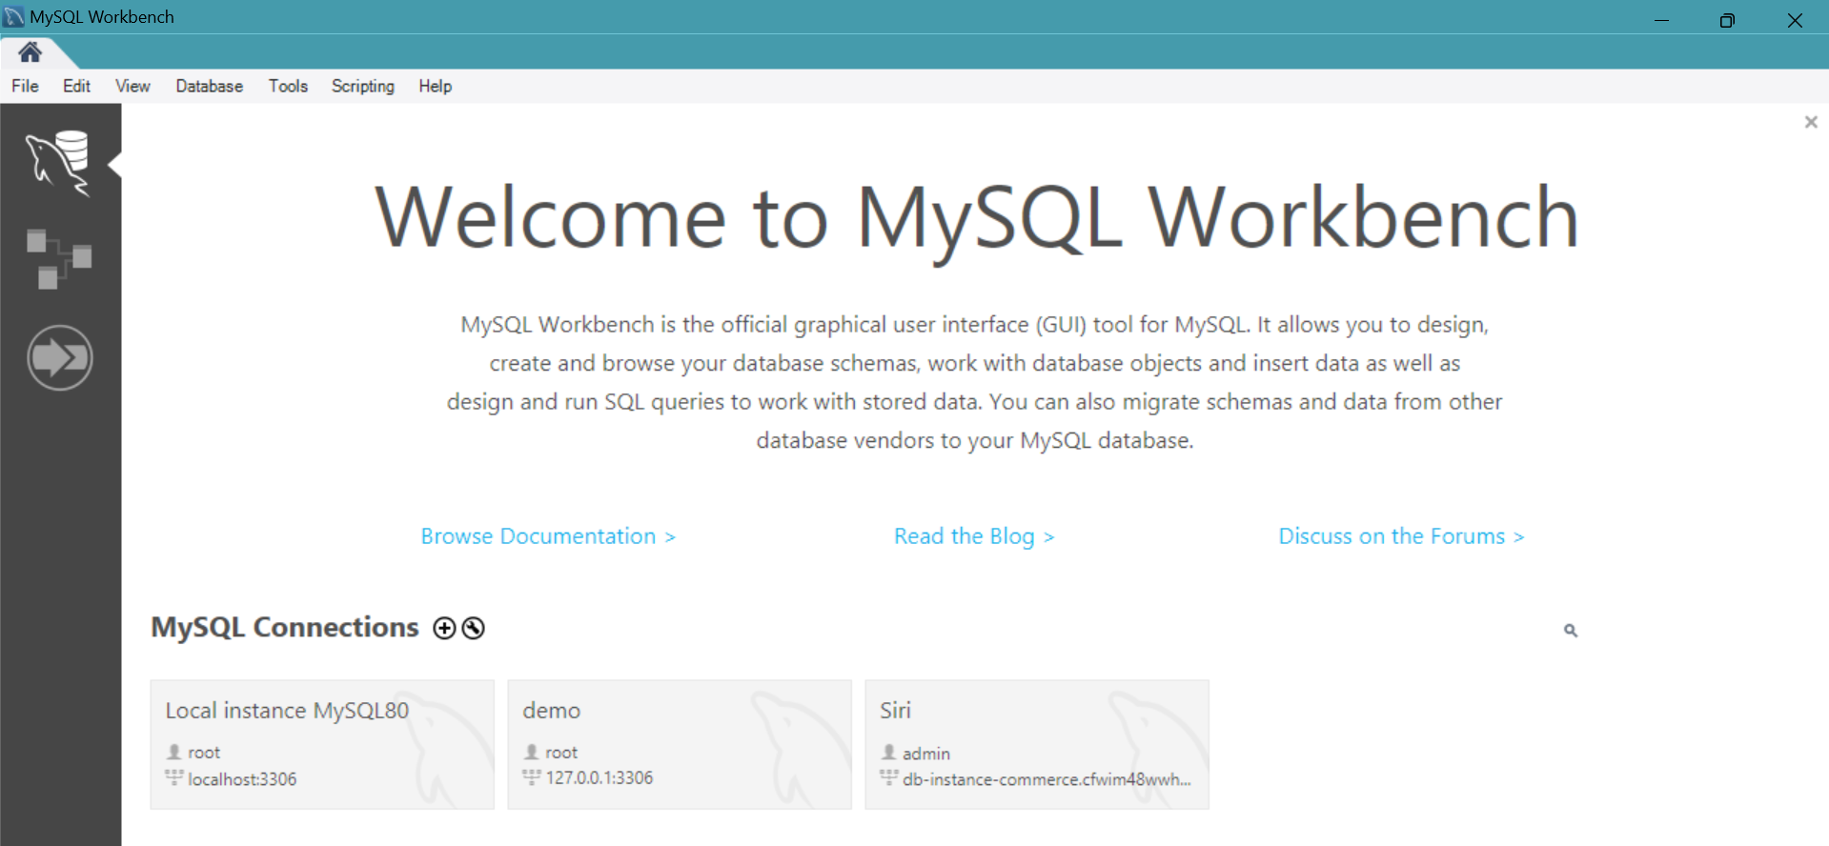

* Connect to the RDS instance via MySQL Workbench using the endpoint and credentials from AWS

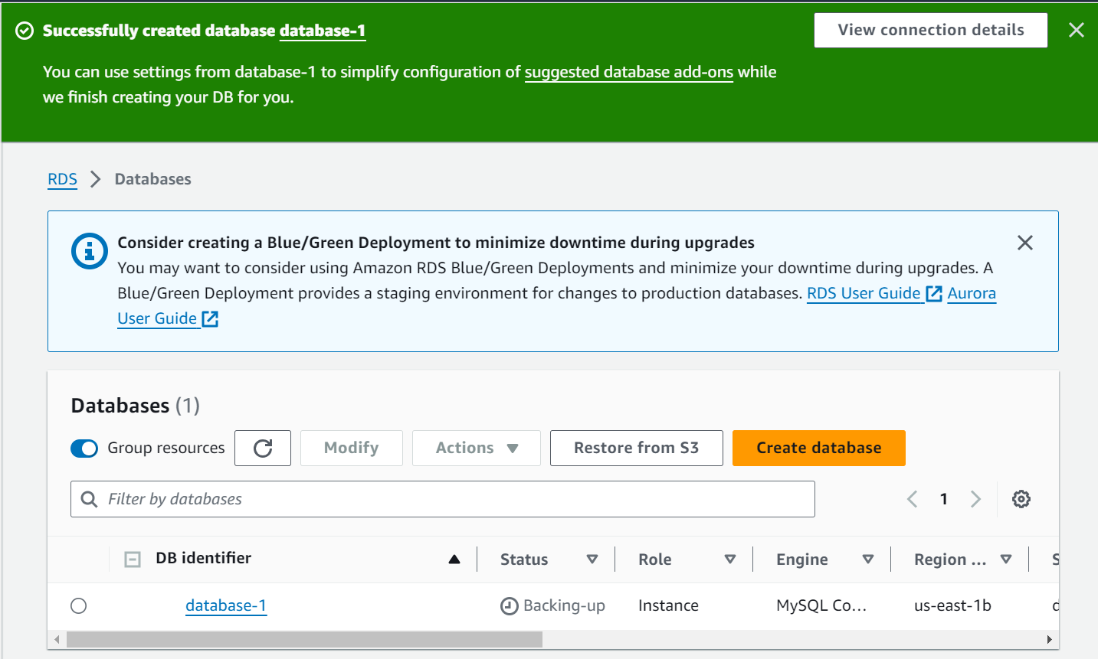

* Once the database is created, click on it.

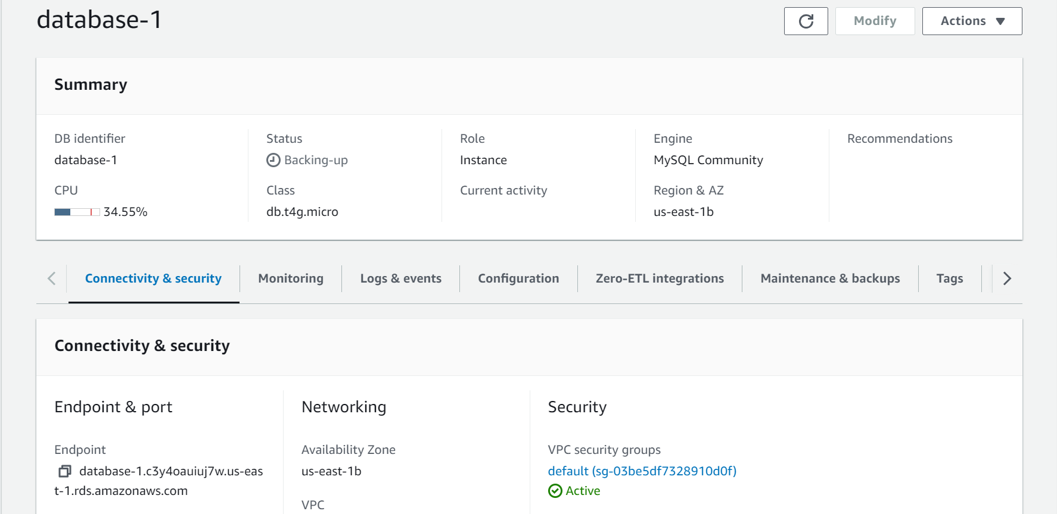

* Copy the Endpoint

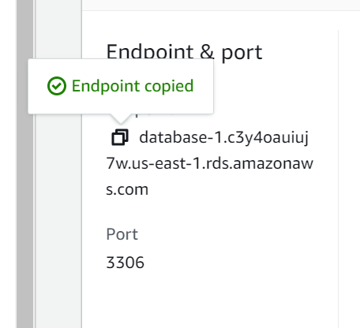

* Paste the endpoint in the Hostname
* Click on Store in Vault beside password

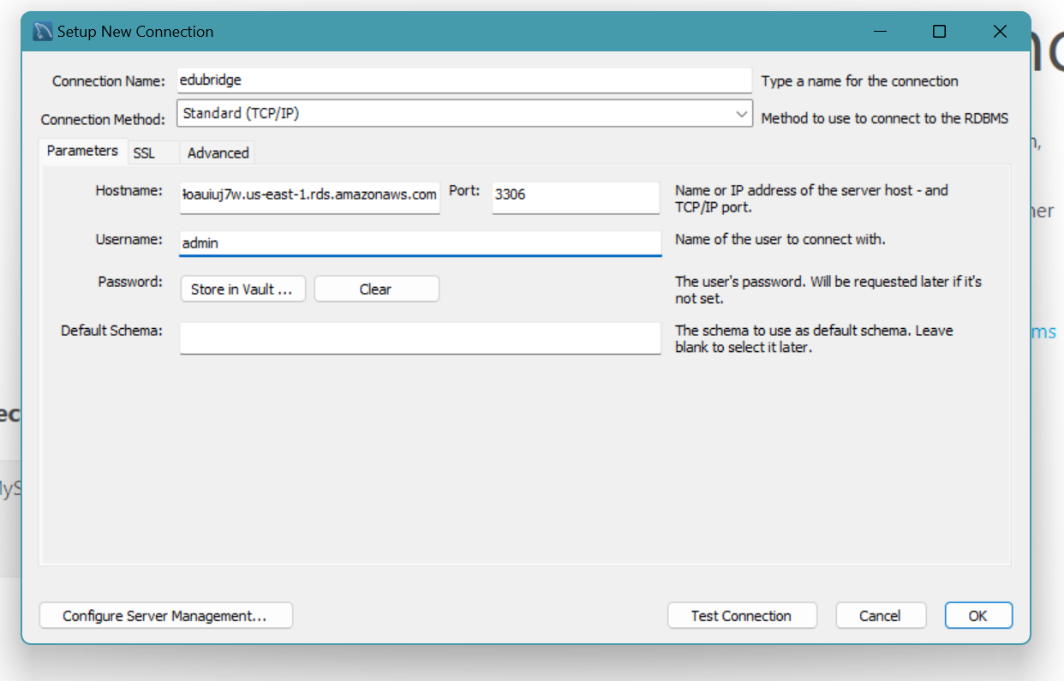

* Enter the password that is created in RDS, Click OK

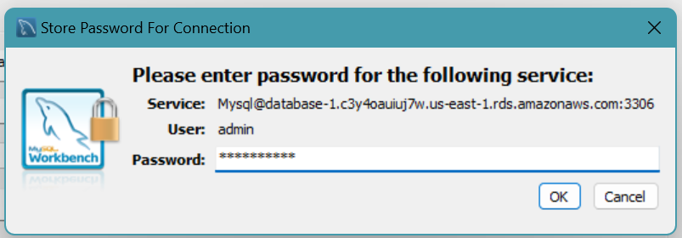

* Then , Click on Test Connection

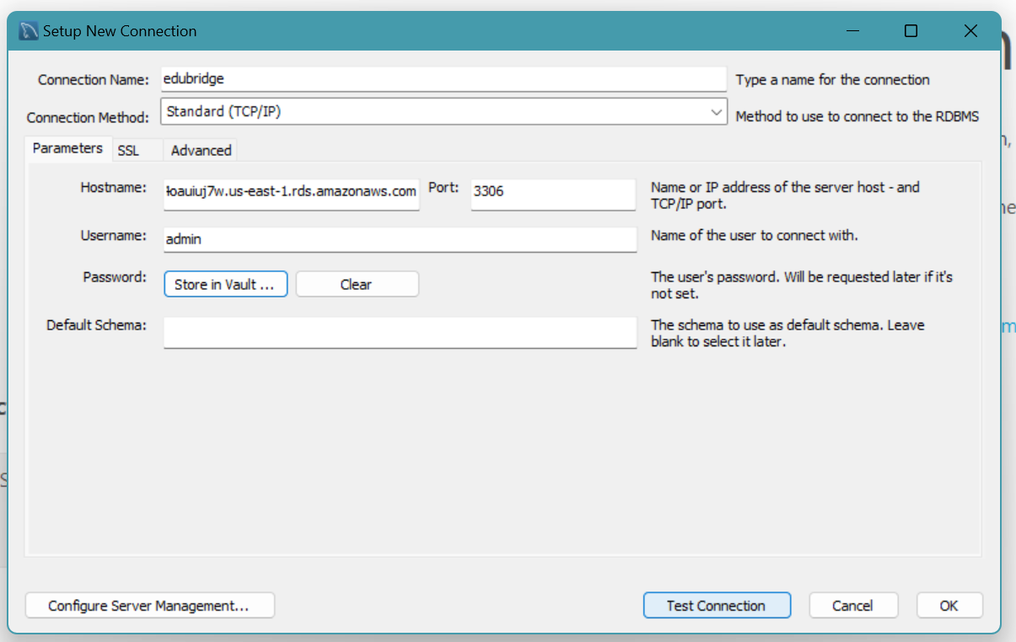

* MySQL Connection is made successfully.

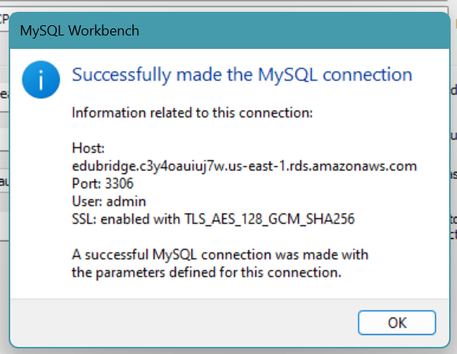

* Click on OK, The SQL Editor will open.

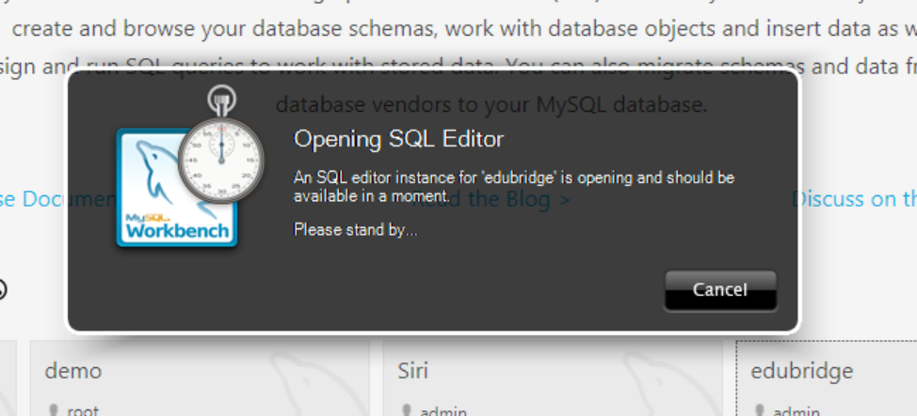

* The new SQL editor will welcome you this way,

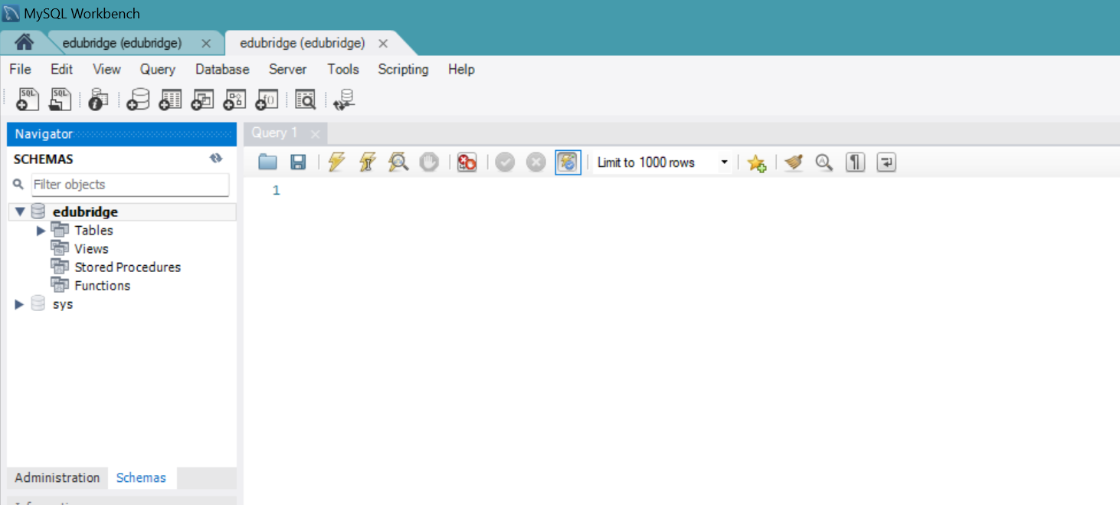

**Activity 2.4:** Create the Database and the tables which are required.

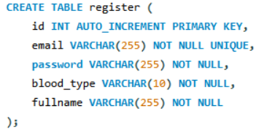

id INT AUTO_INCREMENT PRIMARY KEY: Automatically generated unique integer identifier for each user.

email VARCHAR(255) NOT NULL UNIQUE: User's email, must be unique and cannot be null.

password VARCHAR(255) NOT NULL: User's password, cannot be null.

blood_type VARCHAR(10) NOT NULL: User's blood type, cannot be null.

Full name VARCHAR(255) NOT NULL: User's full name, cannot be null.

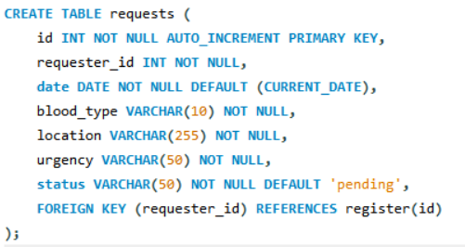

id: Auto-incremented primary key that uniquely identifies each request.

requester_id: A foreign key linking to the register table

date: Stores the date of the request. By default, it uses CURRENT_DATE if no date is provided.

blood_type: The blood type requested, such as 'A+', 'B+', etc.

location: The location where the request is made (in your example, all are in Hyderabad).

urgency: The urgency level of the request, such as 'High', 'Medium', etc.

status: The status of the request, which defaults to 'pending'.

**Milestone 3: Web Development and integration**

In this milestone, we will develop the BloodBridge web application with user registration, login, and dashboard features.

**Activity 1: Set Up Development Environment**

1. Choose your preferred backend framework (e.g., Express.js for Node.js or Flask for Python).
2. Set up the project structure and install necessary dependencies.

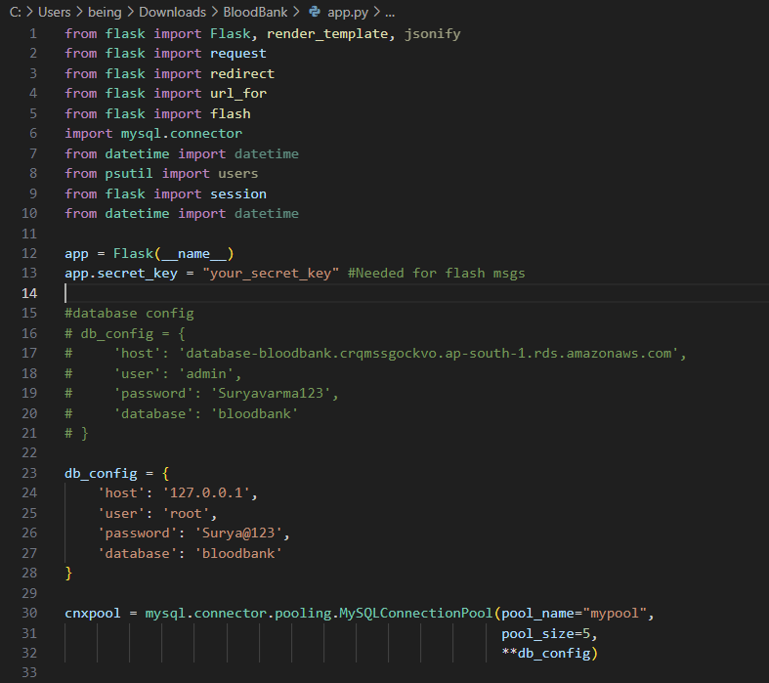

1. Setting Up Flask Application:

* The application starts by importing necessary modules such as Flask, MySQL connector, session handling, and other utilities like datetime.
* app = Flask(__name__): Initializes a Flask web application.
* app.secret_key = "your_secret_key": This key is necessary for securely handling sessions and flash messages (temporary notifications).

2. Database Connection:

* Two sets of database configuration (db_config) are defined: one for a local MySQL database (127.0.0.1) and another commented out version for a remote AWS RDS instance.
* A connection pool is created using mysql.connector.pooling.MySQLConnectionPool, which allows up to 5 simultaneous connections.

The get_db_connection() function retrieves a connection from the pool.

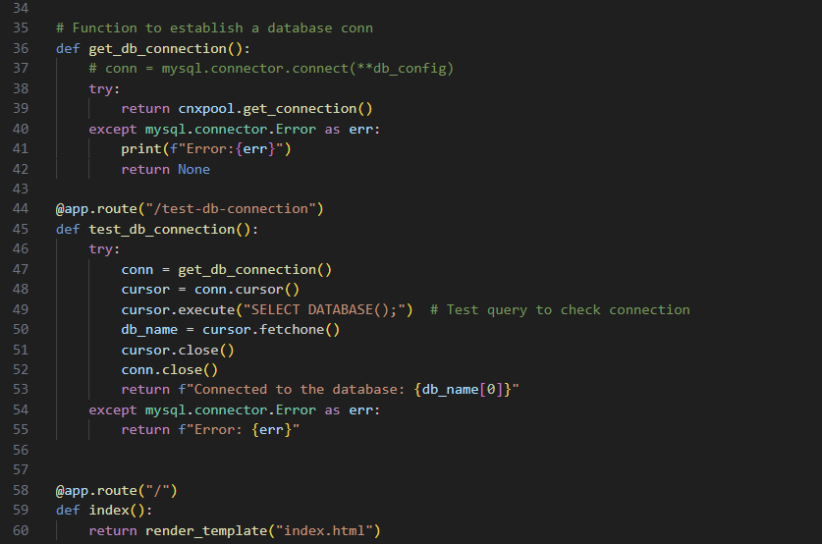

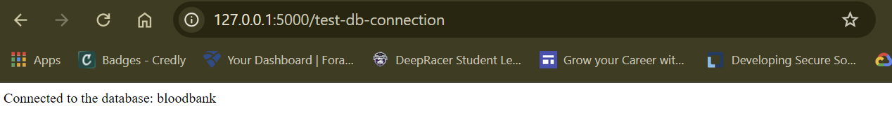

Testing the Database Connection:

* A test route /test-db-connection is used to verify if the application can connect to the database by executing a simple SQL query: SELECT DATABASE();.

4. Home Route (/):

* The index() function returns the main HTML page (index.html).

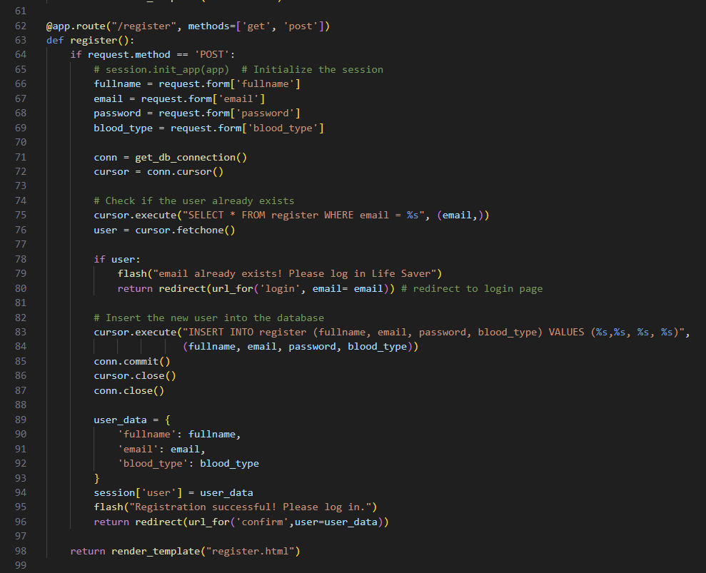

5. User Registration (/register):

* The user submits a registration form with details like fullname, email, password, and blood_type.

It checks if the email already exists in the database using:  
python  
Copy code  
cursor.execute("SELECT * FROM register WHERE email = %s", (email,))

* If the email exists, the user is redirected to the login page, and a flash message is shown.

If the user is new, their details are inserted into the database:  
python  
Copy code  
cursor.execute("INSERT INTO register (fullname, email, password, blood_type) VALUES (%s,%s, %s, %s)", (fullname, email, password, blood_type))

* Session data is created for the user, and the user is redirected to a confirmation page.

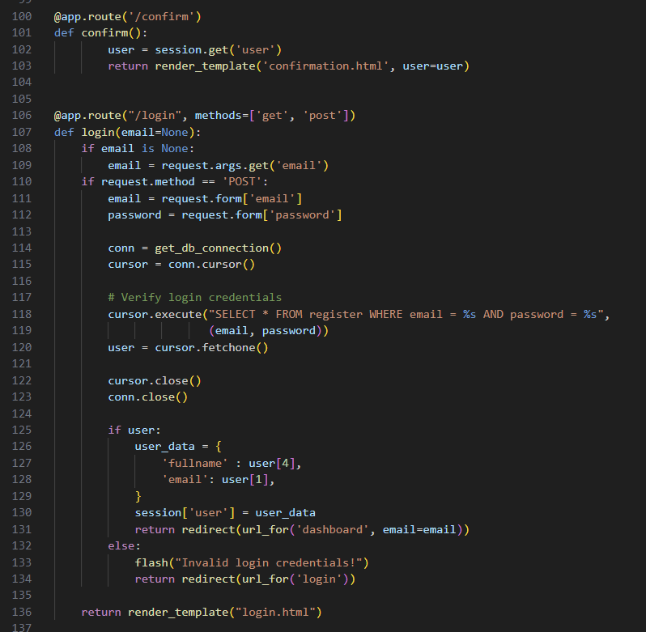

6. User Login (/login):

* A login form accepts the email and password.
* These credentials are verified by querying the database. If they match, the user is redirected to the dashboard, and session data is stored:  
  python  
  Copy code  
  cursor.execute("SELECT * FROM register WHERE email = %s AND password = %s", (email, password))

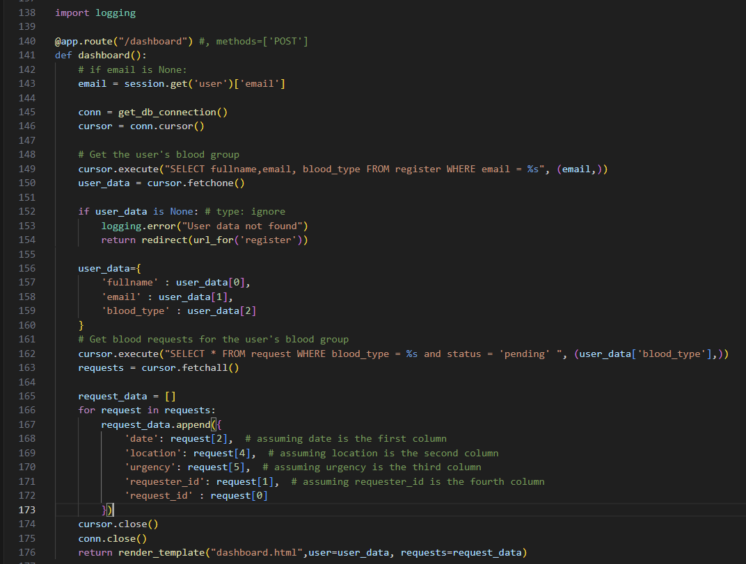

1. Session retrieval

- It fetches the current user's email from the session (`email = session.get('user')['email']`).

2. Database connection:

- A connection to the database is established using `get_db_connection()`.

3. Fetching user data:

- The query fetches the full name, email, and blood type of the logged-in user from the `register` table based on their email.

4. Blood requests retrieval:

- It retrieves all pending blood requests matching the user’s blood type from the `request` table. This helps users see relevant requests.

5. Data display:

- Finally, the `dashboard.html` template is rendered, showing the user data and matching blood requests.

The dashboard serves as a central page for users to view requests related to their blood type.

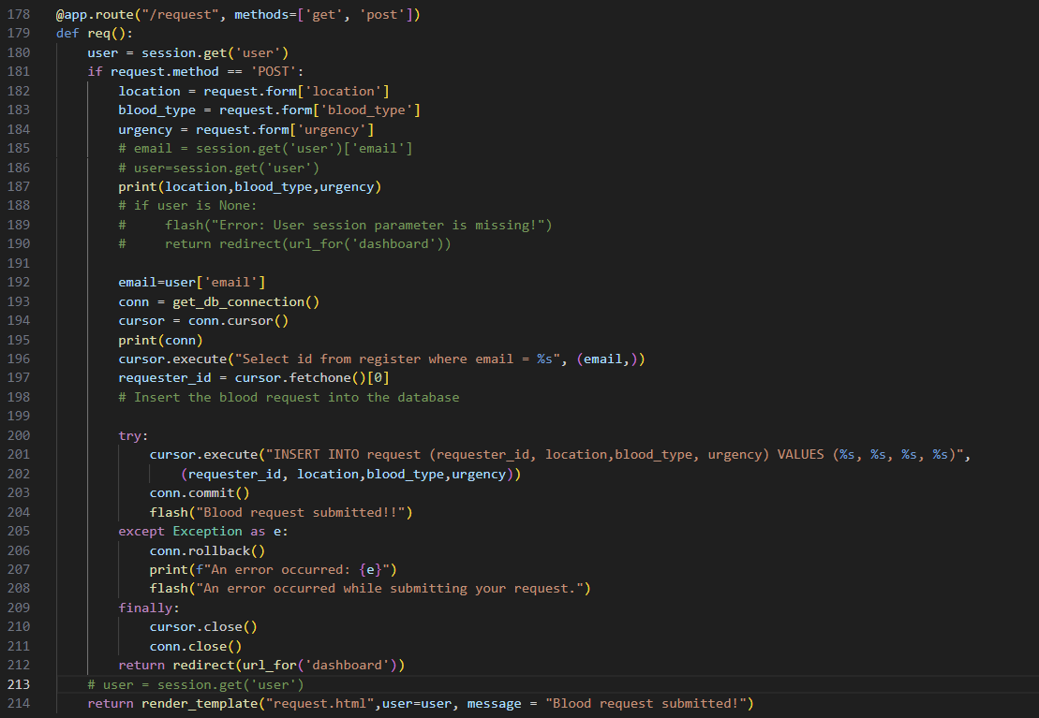

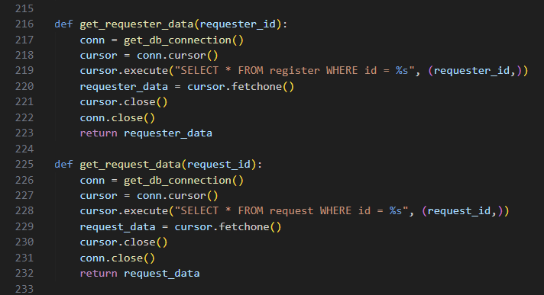

Session retrieval:

* It first checks the session for the logged-in user's details (using session.get('user')).

Form submission (POST request):

* If the request method is POST, the form data (location, blood type, urgency) is retrieved from the user input.

Database connection and insertion:

* A database connection is created using get_db_connection(). The code then fetches the requester_id (from the register table) based on the user's email.
* The user's blood request is inserted into the request table.

Error handling and response:

* The request is committed to the database, and if any error occurs, it is handled by rolling back the transaction.
* If the request is successful, a success message is flashed, and the user is redirected to the dashboard page.

Template rendering (GET request):

* For a GET request (when the page is first accessed), it renders the request.html template, displaying the form for submitting blood requests.

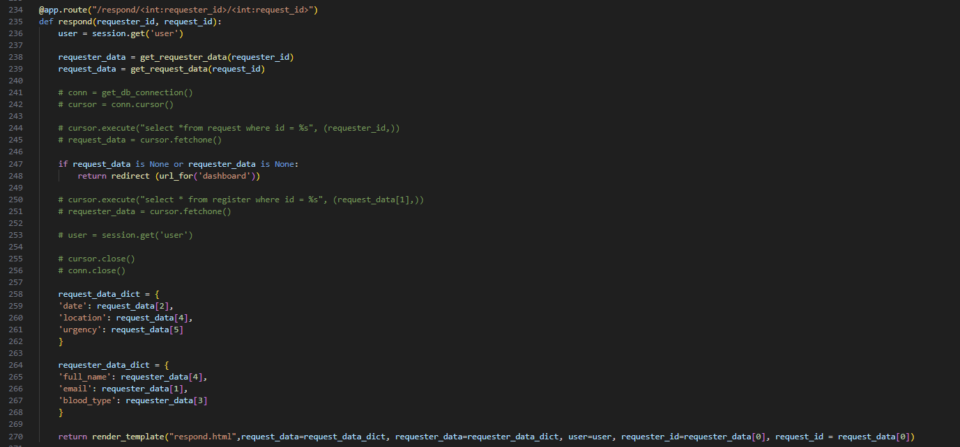

Responding to a Request (/respond/<int:requester_id>/<int:request_id>):

* When another user wants to respond to a blood request, the respond() function fetches both the requester and request details using helper functions (get_requester_data() and get_request_data()).
* The data is passed to respond.html where the user can confirm their donation.

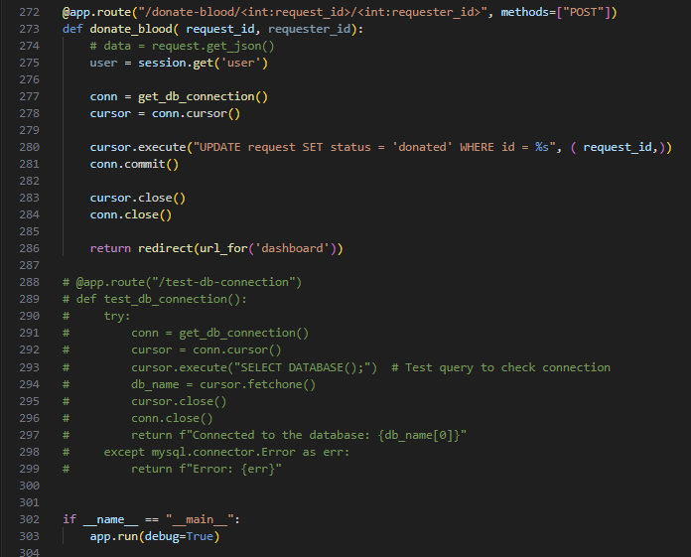

Donation Confirmation (/donate-blood/<int:request_id>/<int:requester_id>):

This route handles the blood donation confirmation by updating the request status to 'donated' in the database:  
cursor.execute("UPDATE request SET status = 'donated' WHERE id = %s", (request_id,))

11. Session and Flash Messaging:

* Flask’s session is used to store user information temporarily across multiple routes.
* flash() is used to send feedback messages to the user, which are displayed when the page is rendered.

12. Running the App:

* The application runs with app.run(debug=True), meaning it will restart automatically if changes are made to the code during development.

**Activity 2: Implement User Authentication**

1. Create registration and login routes and forms.
2. Implement user authentication logic, including password hashing and session management.

**Activity 3: Develop User Dashboard**

1. Create a dashboard interface displaying user information and blood request options.
2. Implement blood request submission and tracking functionality.

**Activity 4: Integrate with RDS Database**

1. Set up database connection using appropriate drivers (e.g., mysql2 for Node.js).
2. Implement database queries for user management and blood request handling.

**Milestone 4: Launching an EC2 instance**

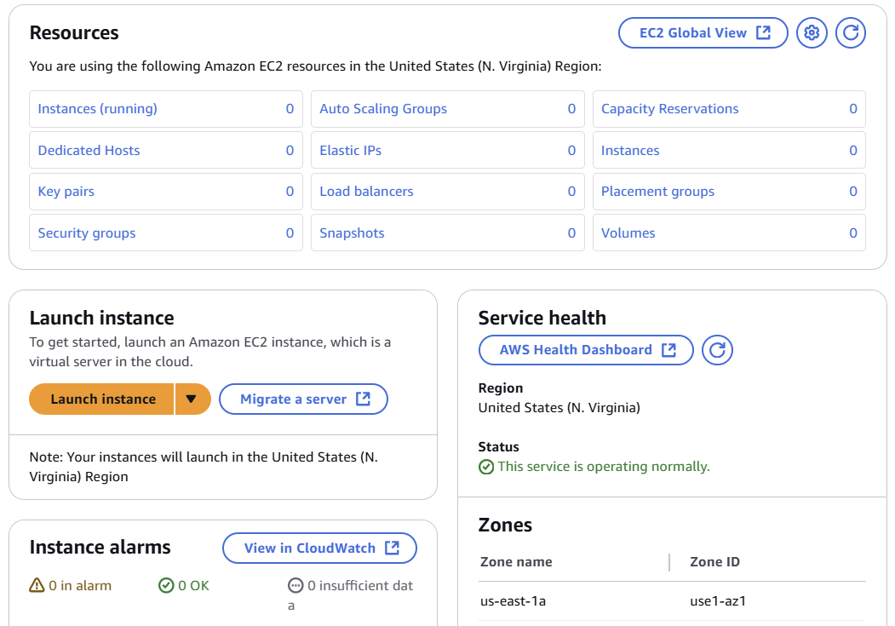

This is the EC2 instance console page where you need to click on the launch instance to create a new instance or click on the instances to go with the running instances

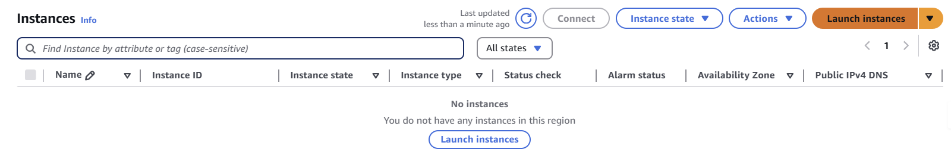

* When you go for the instances(running) option in the above image you will be seeing this interface.
* Now click on the launch instance option

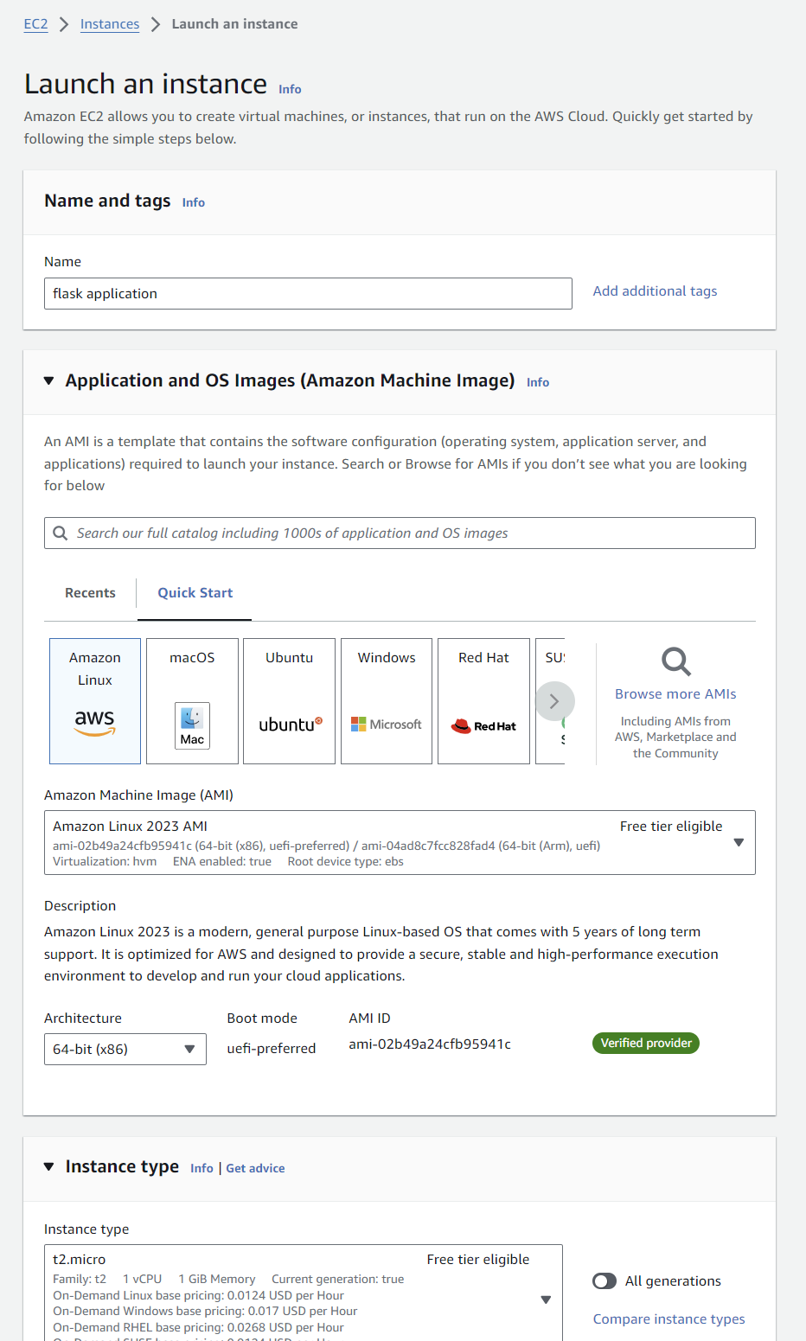

Select the Amazon Linux AMI to proceed further using the ec2 instance and choose the t2.micro instance as this project has a general purpose requirement.

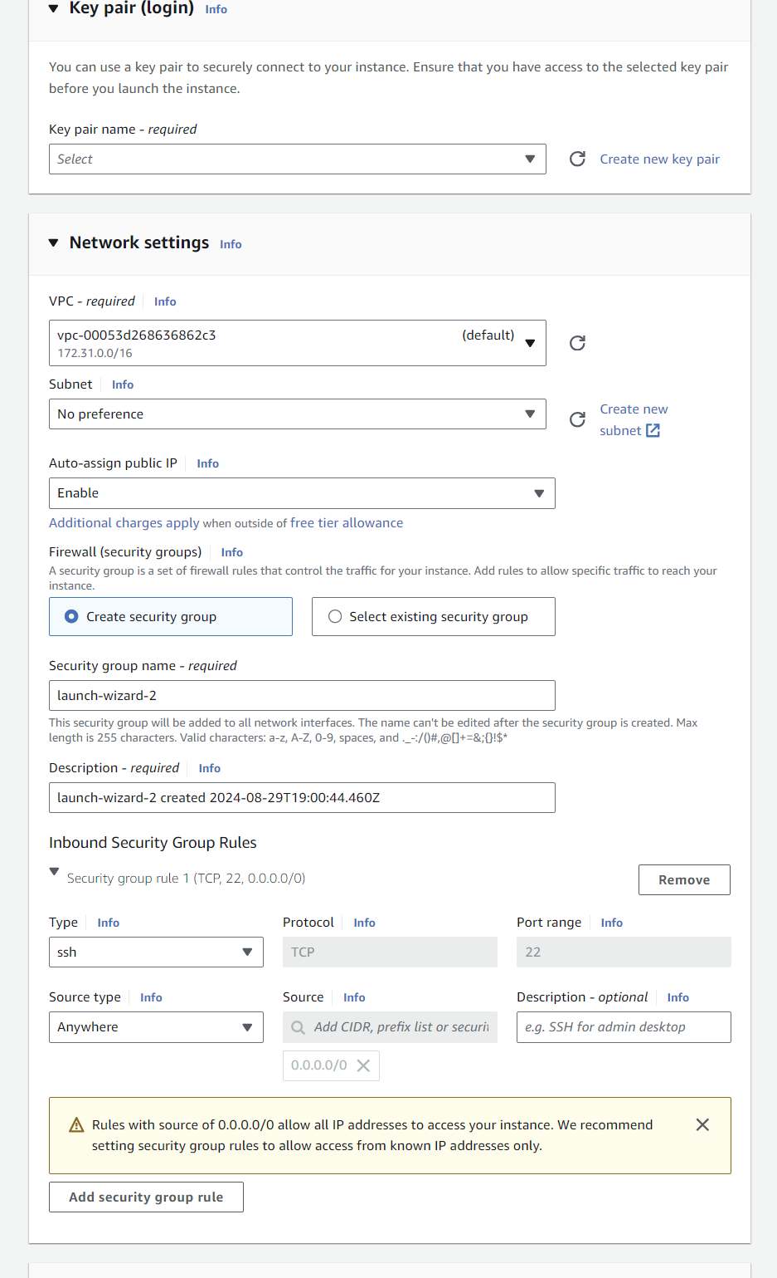

Select the no key pair for the authentication process and proceed to the networking settings

In the networking settings select the VPC you have created for your project if not select the default VPC( make sure to stop the services after using them, VPC also will charge you based upon the As per [**New – AWS Public IPv4 Address Charge + Public IP Insight**](https://aws.amazon.com/blogs/aws/new-aws-public-ipv4-address-charge-public-ip-insights/?sc_channel=sm&sc_campaign=Support&sc_publisher=REDDIT&sc_country=global&sc_geo=GLOBAL&sc_outcome=AWS%20Support&sc_content=Support&trk=Support&linkId=310531300), you'll get billed $0.005/hour = 0.12/day.)

Edit the VPC security settings, edit the security configurations of the ec2 which you need to define to allow the incoming and outgoing traffic from your website.



This is the successful ec2 running after passing the security checks

## **Milestone 5: Testing and Deployment**

**Activity 1: Deploy to EC2**

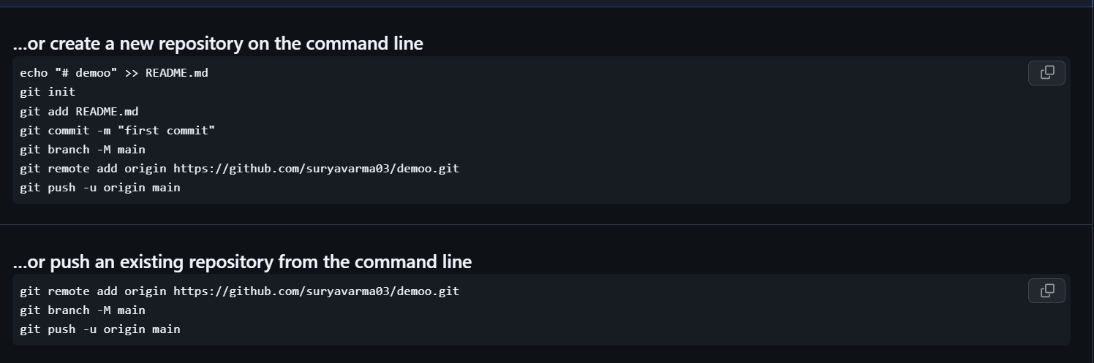

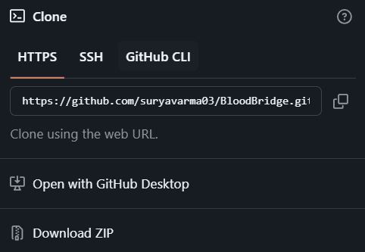

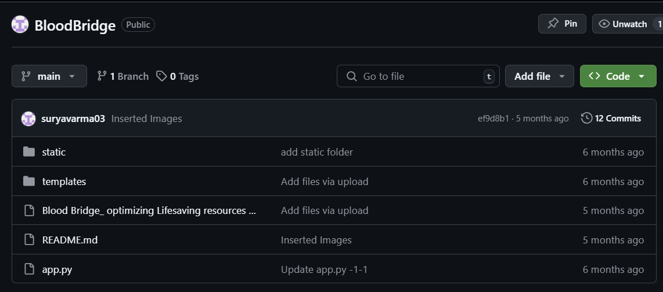

These are the commands for uploading the files from local to your git and from here it is required to deploy in the ec2 terminal.

1. Transfer your application code to the EC2 instance.
2. Set up any necessary environment variables, including database connection strings.
3. Configure the web server to serve your application.
4. Start your application and ensure it's accessible via the EC2 instance's public IP or domain.
5. Run the below commands on ec2 terminal
6. sudo yum update -y
7. sudo yum install python3 -y
8. sudo pip3 install virtualenv
9. python3 -m venv venv
10. source venv/bin/activate
11. pip install flask
12. git clone <https://github.com/your-repo/your-flask-app.git> (replace it with your own link)
13. cd your-flask-app
14. python3 app.py  
      
    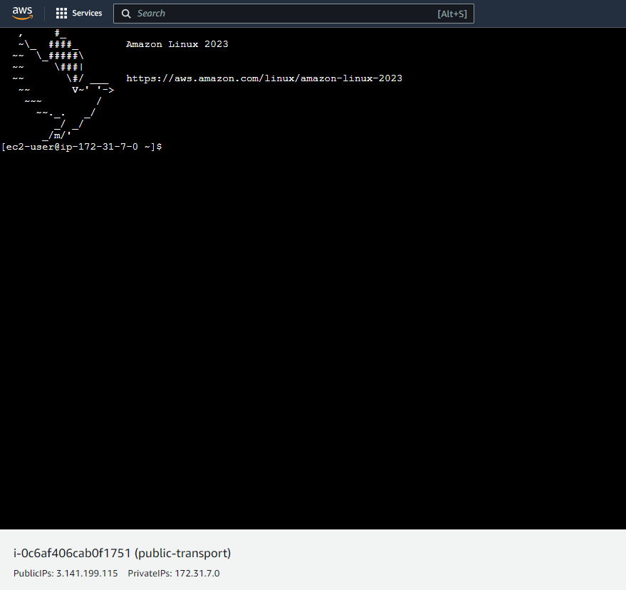

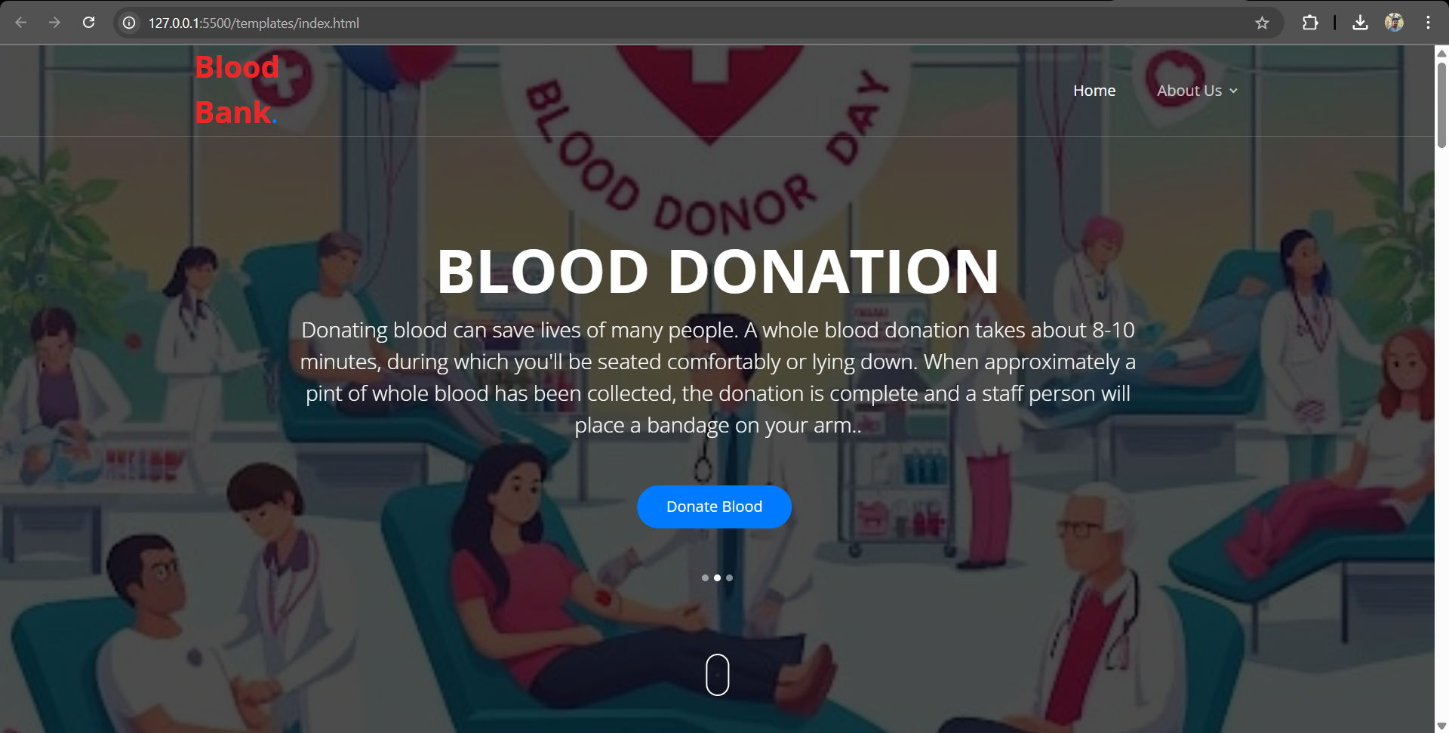

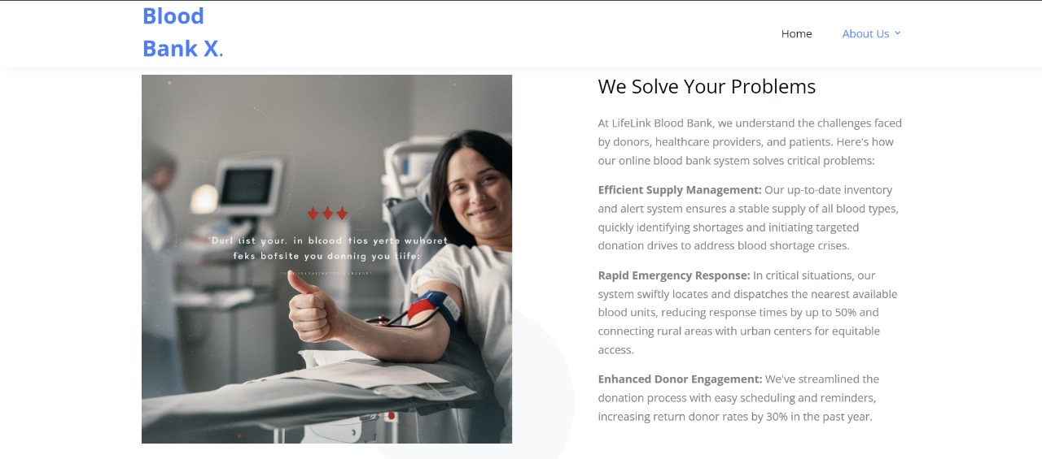

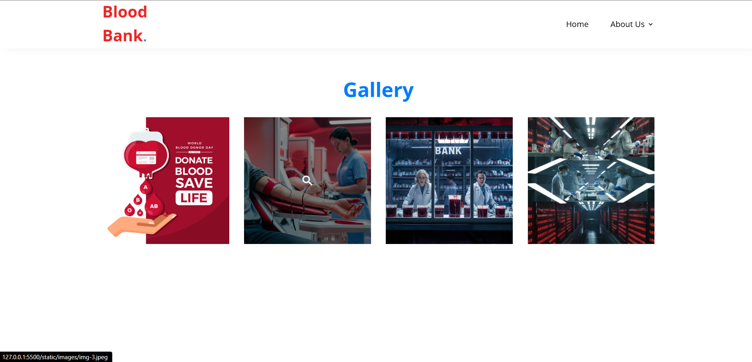

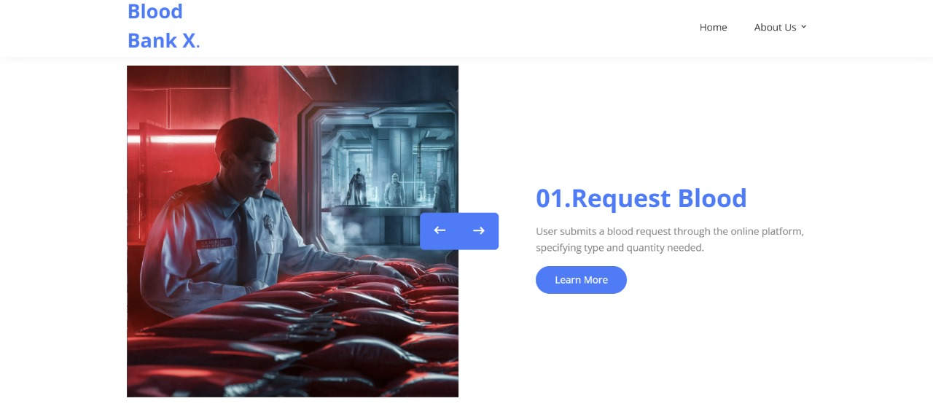

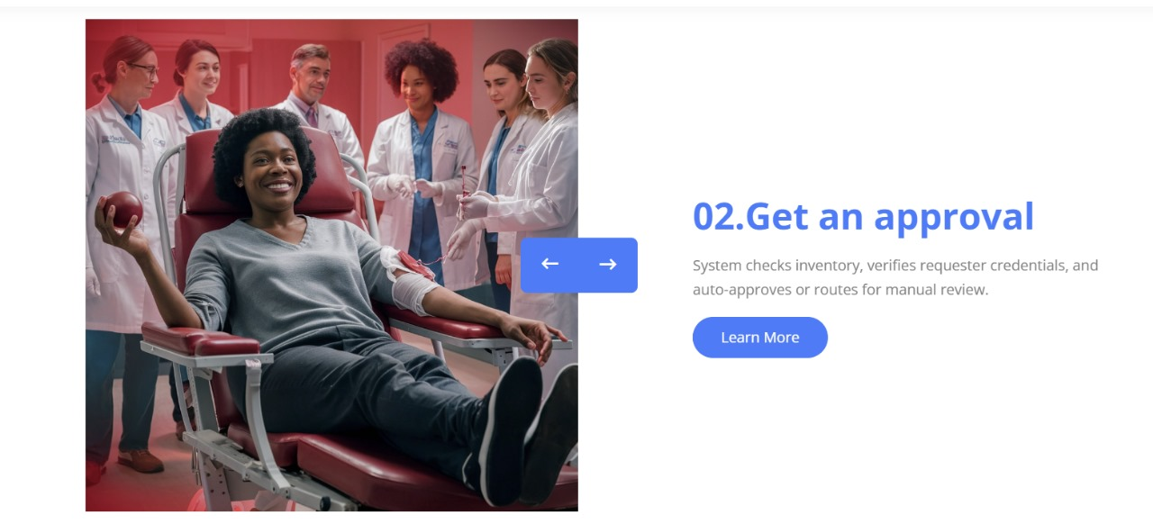

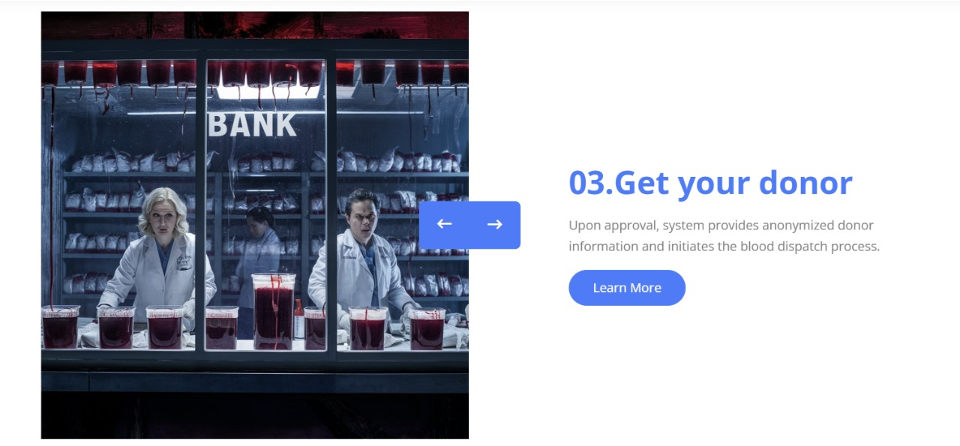

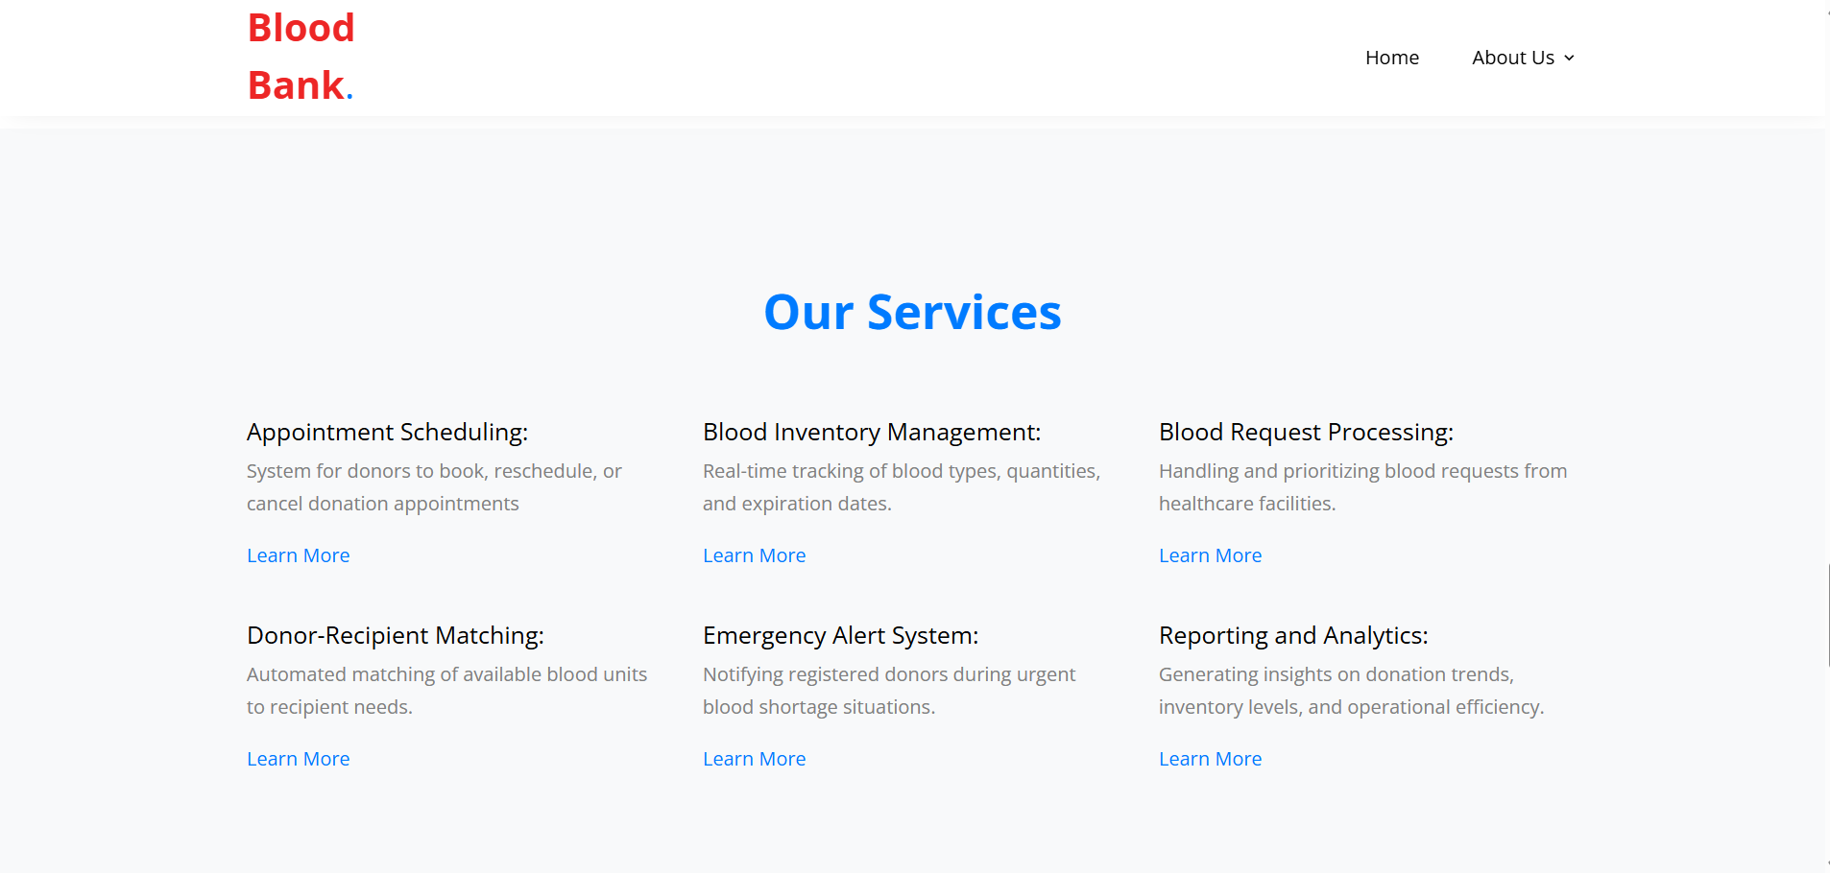

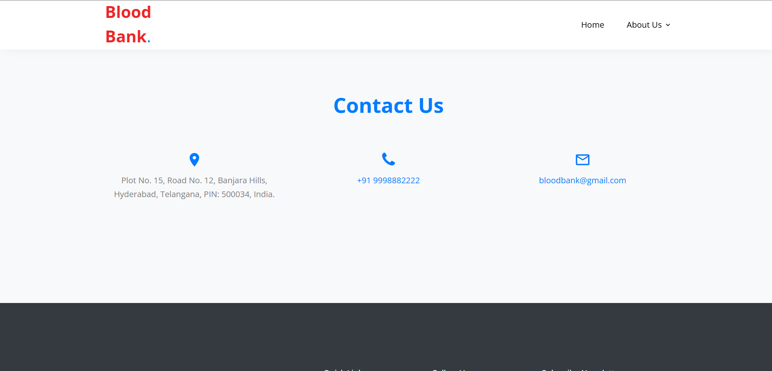

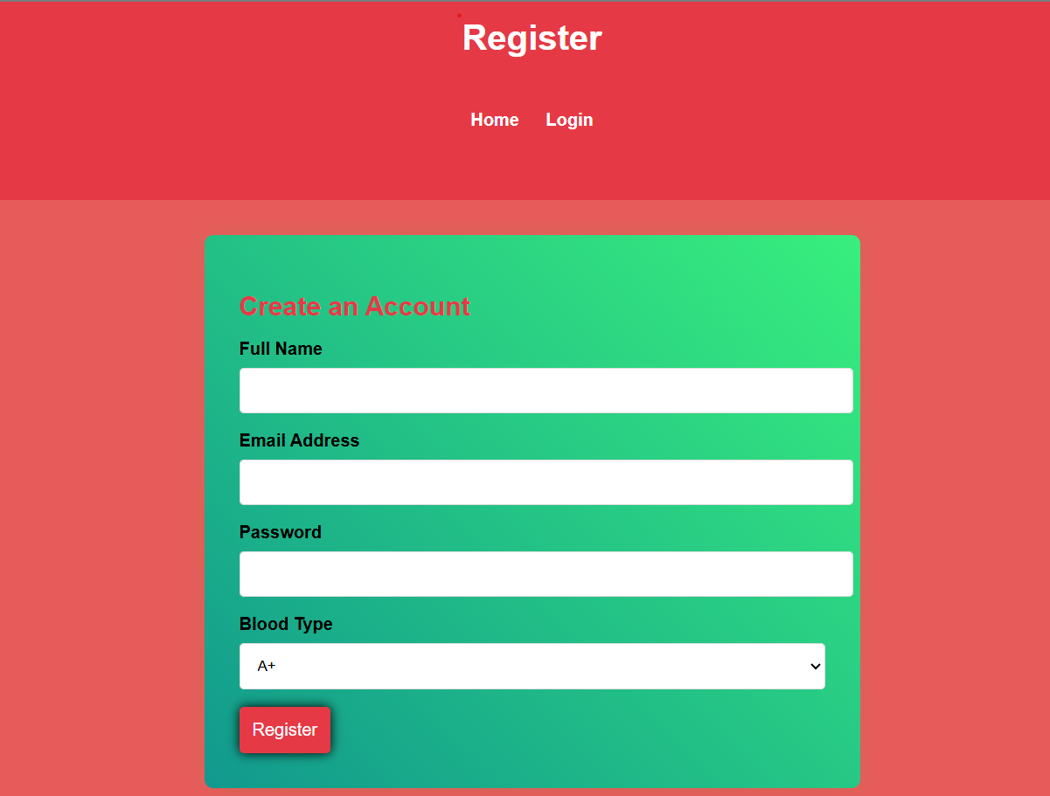

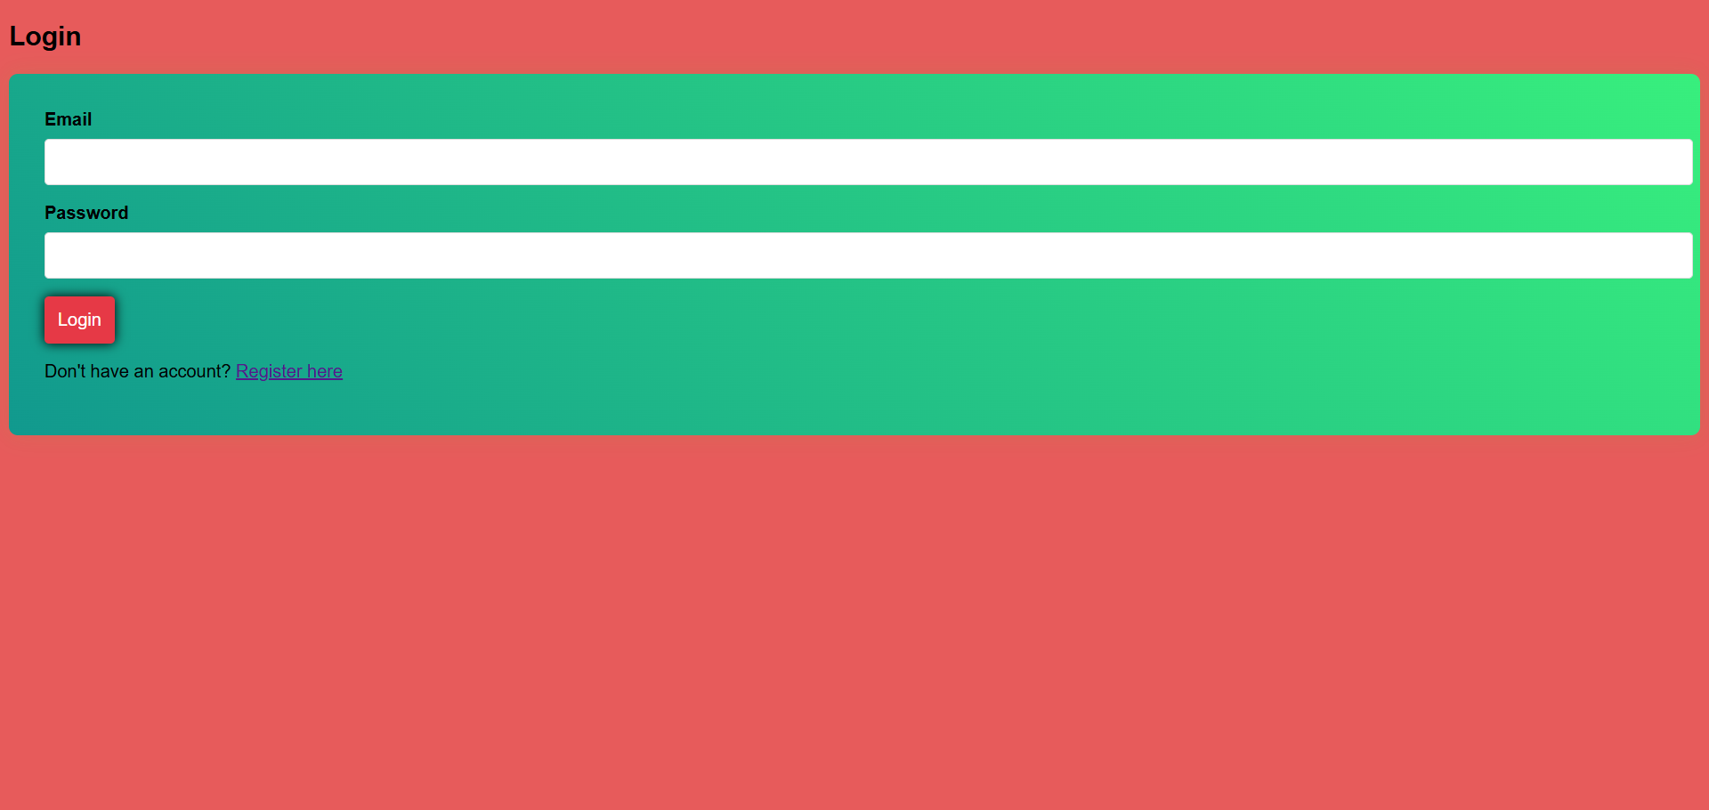

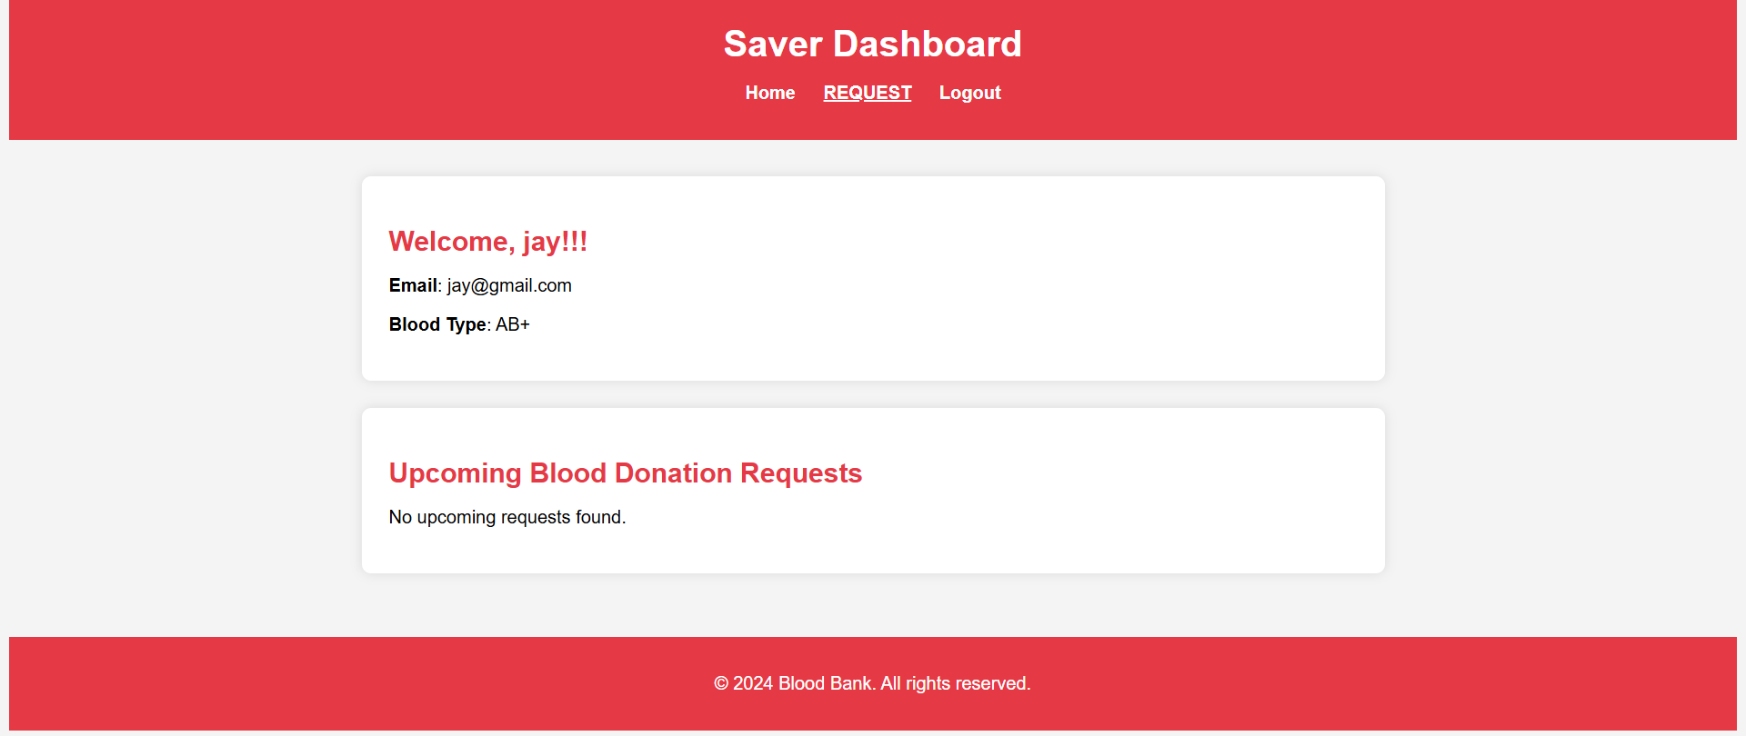

**Conclusion**:

This document provides a comprehensive guide for setting up the BloodBridge platform using AWS services, emphasizing the key steps involved in creating an RDS database, developing a Flask application, and deploying it on an EC2 instance. By adhering to these milestones and activities, you can establish a robust, scalable web application tailored to efficiently manage blood donation requests. Leveraging EC2 for web hosting and RDS for database management ensures a high-performance, reliable infrastructure that can grow with the needs of your application.